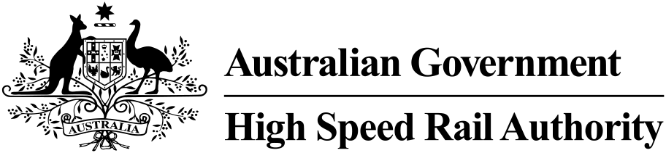

Annual Report 2023–24



© Commonwealth of Australia 2024

ISSN 2982–1517 (Print)  
ISSN 2982–1525 (Online)  
October 2024

Ownership of intellectual property rights in this publication

Unless otherwise noted, copyright (and any other intellectual property rights, if any) in this publication is owned by the Commonwealth of Australia (referred to below as the Commonwealth).

Disclaimer

The material contained in this publication is made available on the understanding that the Commonwealth is not providing professional advice, and that users exercise their own skill and care with respect to its use, and seek independent advice if necessary.

The Commonwealth makes no representations or warranties as to the contents or accuracy of the information contained in this publication. To the extent permitted by law, the Commonwealth disclaims liability to any person or organisation in respect of anything done, or omitted to be done, in reliance upon information contained in this publication.

Creative Commons licence

With the exception of (a) the Coat of Arms; (b) the High Speed Rail Authority’s photos and graphics, copyright in this publication is licensed under a Creative Commons Attribution 4.0 Australia Licence.

Creative Commons Attribution 4.0 Australia Licence is a standard form licence agreement that allows you to copy, communicate and adapt this publication provided that you attribute the work to the Commonwealth and abide by the other licence terms.

Further information on the licence terms is available from <https://creativecommons.org/licenses/by/4.0/>

This publication should be attributed in the following way:

© Commonwealth of Australia 2024

Use of the Coat of Arms

The Department of the Prime Minister and Cabinet sets the terms under which the Coat of Arms is used. Please refer to the Commonwealth Coat of Arms – Information and Guidelines publication available at [https://www.pmc.gov.au](https://www.pmc.gov.au/honours-and-symbols/commonwealth-coat-arms).

Contact us

This publication is available online at   
<https://www.transparency.gov.au/publications>.

All other rights are reserved, including in relation to any Authority logos or trademarks which may exist. For enquiries regarding the licence and any use of this publication, please contact:

High Speed Rail Authority  
GPO Box 594  
Canberra ACT 2601  
Australia

Phone: (02) 6274 7111  
Email: [corporate@hsra.gov.au](mailto:corporate@hsra.gov.au)  
Website: [www.hsra.gov.au](http://www.hsra.gov.au)

# Letter of Transmittal to the responsible Minister



The Hon Catherine King MP  
Minister for Infrastructure, Transport, Regional Development and Local Government  
Parliament House  
CANBERRA ACT 2600

Dear Minister,

I am pleased to present the Annual Report of the High Speed Rail Authority (the Authority) for the year ending 30 June 2024.

The report has been prepared as required under section 46 of the Public Governance, Performance and Accountability Act 2013 (PGPA Act) for your presentation to the Parliament, and as required by sections 39(1)(b) and 43(4) of the PGPA Act, the report includes the Authority’s annual performance statements and audited financial statements.

The reporting period for this Annual Report is 12 June 2023 to 30 June 2024. The Department of Finance provided a signed nomination under subsection 17J(3) of the Public Governance, Performance and Accountability Rule 2014 (PGPA Rule) for the Authority’s first reporting period to be 12 June 2023 to 30 June 2024 in accordance with section 7AC of the PGPA Rule.

This report has been approved by a resolution of the High Speed Rail Authority Board as the Accountable Authority in reliance on assurance management certification provided by the Authority’s CEO, that during the reporting period:

* in accordance with sections 17AG and 17BE of the Public Governance, Performance and Accountability Rule 2014 (PGPA Rule), there were no significant issues of non‑compliance notified; and
* in accordance with sections 10 and 17AG of the PGPA Rule, a fraud risk assessment and fraud control plan were prepared for the Authority, appropriate mechanisms were in place for preventing, detecting, investigating and reporting fraud that met the specific needs of the Authority, and all reasonable measures were taken to deal appropriately with fraud relating to the Authority.

Following the tabling of the Authority’s Annual Report, the report will be made available on the Australian Government’s Transparency Portal [www.transparency.gov.au](http://www.transparency.gov.au) as well as on the Authority’s website [www.hsra.gov.au](http://www.hsra.gov.au).

Yours sincerely

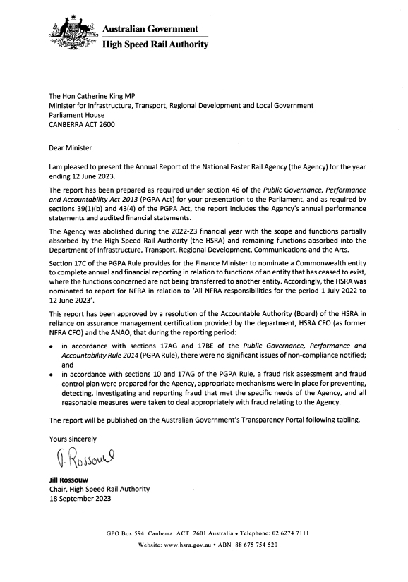

**Jill Rossouw**Chair, High Speed Rail Authority

16 September 2024

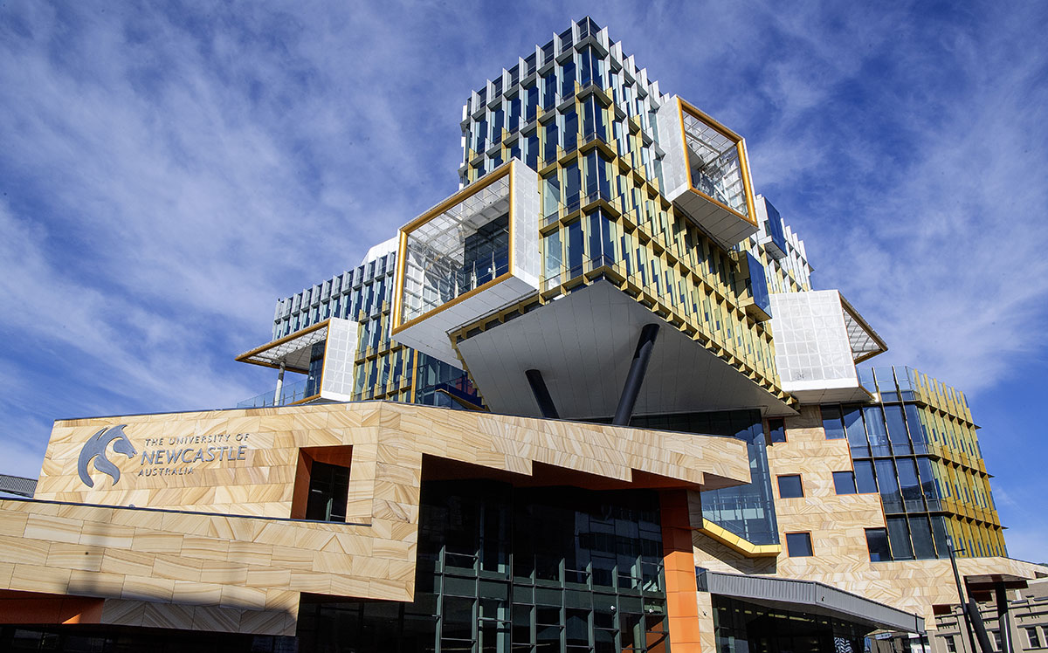

Contents

Letter of Transmittal to the responsible Minister 3

Chair’s foreword 6

Section 1 CEO’s review 7

Section 2 Performance statement 9

Statement of preparation 10

Portfolio Budget Statement and Corporate Plan 10

Performance results 10

Section 3 Governance and accountability 13

Corporate governance 14

Board and committees 15

Other legislative reporting requirements 18

Section 4 Organisational profile 23

Structure and location 24

Values 25

People 25

Executive remuneration 27

Section 5 Financial performance 31

Section 6 Reference information 54

List of annual report requirements 55

The High Speed Rail Authority acknowledges the traditional owners of Country throughout Australia and their continuing connection to land, sea and community. We pay our respects to them and their cultures, and to the Elders past and present.

# Chair’s foreword

Welcome to the inaugural annual report for the High Speed Rail Authority (the Authority), a start-up entity, which was established 12 June 2023. The Authority was delighted to appoint Tim Parker as the inaugural Chief Executive Officer. Tim joined our organisation in January 2024. We also acknowledge the contribution of Andrew Hyles, who was Acting Chief Executive Officer.

The Australian Government is planning for a future high speed rail network to connect Brisbane, Sydney, Canberra, Melbourne and regional communities across the east coast of Australia. The Authority has been tasked with creating what a future high speed rail network would look like and how it would operate. The proposed first stage is the Newcastle to Sydney connection, a nationally-significant corridor connecting the two largest cities in New South Wales.

New infrastructure like a high speed rail network will create more jobs in more locations, giving people greater choice of where they work and live, while also unlocking more diverse and affordable housing options. Some of the parameters for this development work include a network that can move thousands of people an hour between major cities and regional centres on new world class trains at speeds of more than 250km per hour. A transformational network of this scale delivers massive economic growth opportunities, especially in the development of regional areas including tourism.

It will support sectors like local manufacturing through the National Rail Manufacturing Plan and contribute to Australia’s net zero commitments by delivering a sustainable low-emission form of transport. Through its initial establishment phase, the Authority has worked transparently and implemented a framework of high standards of organisational governance and accountability, including an integrated risk management framework.

In undertaking important foundational and planning activities throughout the year, the Authority has advanced its organisational maturity to ensure it is operating with the requisite systems, processes and resources to enable it to deliver on its objectives. The Authority continues to build the organisation’s capability and capacity, with the focus of the Board including setting and overseeing the Authority’s vision, strategy, organisation culture and resourcing plan.

In 2023–24, the Authority also commenced its work on the business case for the Newcastle to Sydney stage. It is due to be delivered to the Australian Government by the end of 2024, together with a Product Definition Report for the wider east coast network. The Authority is approaching its task through an economic growth framework – with a world-class high speed rail network at its core – designed to deliver generations of benefits to millions of Australians, transforming lives and giving more people greater opportunities.

The Authority’s Board continues to work closely with CEO and his executive team to build the organisation capability as we to focus our efforts on bringing these benefits to life.

Reflecting on the achievements of the 2023–24 year, it has been particularly pleasing to see the Authority build momentum as it delivers on its performance measures.

On behalf of the Board, it is my pleasure to introduce the High Speed Rail’s 2023–24 annual report.



**Jill Rossouw**  
Board Chair



# Section 1 CEO’s review

The High Speed Rail Authority (the Authority) has made significant progress in 2023–24 towards delivering a high speed rail network in Australia.

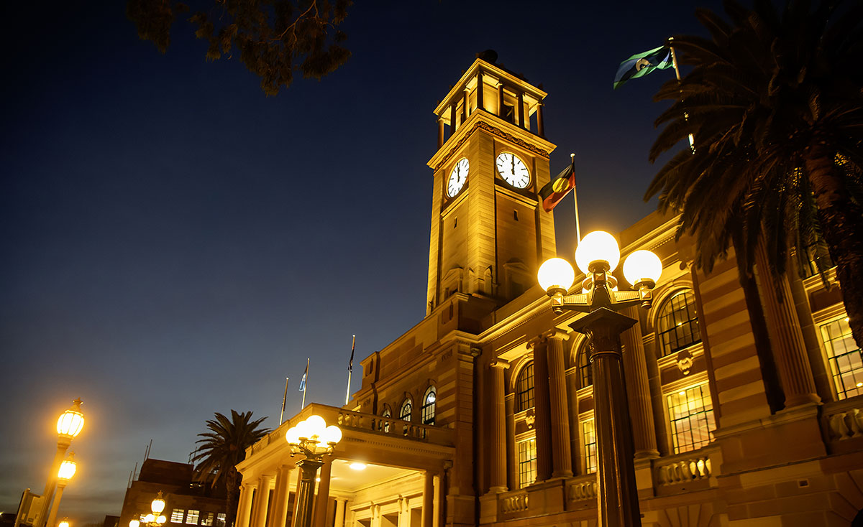

Having been appointed inaugural CEO partway through the year, my focus has been on recruiting and leading our team to ensure we deliver the Newcastle to Sydney Business Case and network wide Product Definition Report to Government by the end of 2024.

Our focus has been clear: this is more than just a railway. High speed rail would deliver many economic, social and environmental benefits as it connects Australian regions, cities and communities with quick, convenient, safe and comfortable high speed rail services.

Journey times from Newcastle to Sydney would be about an hour.

From the Central Coast – 30 minutes to Sydney, and 30 minutes to Newcastle.

As the future network evolves, people could be able to travel from Canberra to Sydney in about 1.5 hours.

Intercity connections such as Sydney to Brisbane or Sydney to Melbourne would take about 4 hours.

I’m always excited by the task at hand, and immensely proud of the work our growing team has being doing to deliver on our requirements.

The Authority has been focussed on establishing the leadership team, engaging expert advisers to help shape and deliver the Business Case building on previous work on high speed rail as we plan for a new network on the east coast of Australia.

The Authority has entered into an agreement with Transport for NSW (TfNSW) to provide resources and a project office support the Authority in delivering the Business Case.

We continue to engage and consult with the community, key stakeholders and industry on an ongoing basis as part of the Business Case to get valuable insight into optimising the outcome.

High speed rail is a major undertaking requiring careful coordination across federal and state governments, significant investment, and long-term planning.

The opportunity that we have right now is significant and I look forward to continuing to work towards delivery of Australia’s very own high speed rail network.

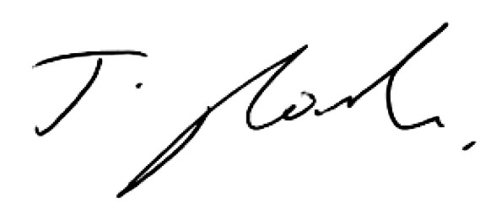

**Tim Parker**Chief Executive Officer

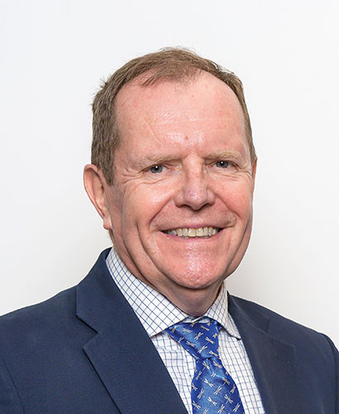

# Section 2 Performance statement



## Statement of preparation

I, Jill Rossouw, on behalf of the Board of the High Speed Rail Authority, present the 2023–24 annual performance statement of the High Speed Rail Authority, as required under section 39(1)(a) of the Public Governance, Performance and Accountability Act 2013 (PGPA Act).

In our opinion, at the date of this statement, based on the material provided to the Board, this annual performance statement accurately reflects the performance of the entity and complies with subsection 39(2) of the PGPA Act.

**Jill Rossouw**On behalf of the High Speed Rail Authority Board

16 September 2024

## Portfolio Budget Statement and Corporate Plan

The Portfolio Budget Statement (PBS) for 2023–24 has a single outcome and one program for the Authority.

### Outcome 1

Developing a high speed rail network between capital cities and key regional centres through policy development and planning, national coordination and strategic advice to enhance Australia’s long term rail investment.

#### Program 1.1

Advice supports the Australian Governments objectives for high speed rail.

The [2023–24 to 2026–27 Corporate](https://previewapi.transparency.gov.au/delivery/assets/80a82ed1-3e33-027b-b7e0-6493f97f18f8/d099e417-8e94-4fb3-8f82-2b3d1284ea93/2023-24%20High%20Speed%20Rail%20Authority%20Corporate%20Plan.pdf) Plan was published in August 2023 and sets out the key activities, performance measures and targets of the Authority. It provides a clear roadmap and aligns operations with the Authority’s overarching objectives.

The performance measures outlined in the Corporate Plan are reported in the following table.

## Performance results

This section provides an assessment of the Authority’s performance during the year and how it contributed to the Authority’s results in achieving its purpose.

The Authority measured its performance through seven performance criteria. Over the reporting period 12 June 2023 to 30 June 2024, the Authority achieved the four targets due by the end of 2023/early 2024 and the remaining three listed at the end of calendar 2024 are on track.

| Performance Measure | 2023–24 Target | Result | Analysis |
| --- | --- | --- | --- |
| Develop a risk management policy and framework. | By the end of 2023, a risk management policy and framework will be developed that will govern how the Authority identifies, manages and communicates risk. | Achieved | The Authority’s risk management policy and framework was endorsed by its Audit and Risk Committee on 29 November 2023.  The Authority also appointed a Risk Manager in 2024 who is working through all aspects of risk management systems, process and activities. The Enterprise Risk and Project Risk registers are dynamic documents and will be updated as necessary. |
| Develop an organisational strategy which includes capability building. | By the end of 2023, an organisational strategy will be developed that provides a road map for developing the organisation and its workforce capability and resource needs to deliver the outcome. | Achieved | The Authority’s Organisational Strategy was finalised in November 2023. |
| Develop a communications and stakeholder engagement strategy. | By early 2024, a communications and stakeholder engagement strategy will outline a framework, including objectives and timeframes, for the Authority to engage with key stakeholders on key initiatives and actions the Authority will take. | Achieved | The Authority ran a merit based recruitment process and a General Manager Stakeholder Engagement and Communications was engaged in June 2024. Subsequently an Overarching Stakeholder and Community Engagement Strategy was developed in June 2024. |
| Appoint a permanent Chief Executive Officer to head the Authority. | By early 2024, a permanent Chief Executive Officer will have been appointed. | Achieved | The Authority ran a merit based recruitment process and the Government formally endorsed the appointment of a permanent CEO in November 2023. The newly appointed CEO commenced on 15 January 2024. |
| Build on the 2013 High Speed Rail Phase 2 Report to support strategic planning for an east coast high speed rail network and development of business cases. | A review of the 2013 Phase 2 Report, Pathway to Delivery Report for an east coast high speed rail network and detailed business case for high speed rail on the Sydney to Newcastle corridor are commissioned and work is underway in partnership with relevant states and the ACT. | On track | The Australian Government committed $78.8 million over two years in additional funding for the Authority to develop the Business Case. The Government announced in January 2024 that the Business Case for Sydney to Newcastle section was expected to be completed by December 2024.  The proposed Pathway to Delivery Report has evolved and will now form part of the proposed Product Definition Report (PDR) that will be developed concurrently with the Business Case for Sydney to Newcastle.  Procurement for all major external advisers to develop the Business Case and Product Definition Report has been completed.  A detailed work program for the development of the Business Case and Product Definition Report has been developed with completion scheduled by the end of 2024. |
| Develop a strategy to progress state and federal environmental approvals. | By the end of 2024, a strategy to progress state and federal environmental approvals, including a stocktake of the existing frameworks and options for addressing any challenges associated with location-specific issues. | On track | Developed initial assessment of options/requirements for state and federal environmental approvals.  Completed analysis of indicative environmental and planning impacts of the project.  Commenced discussions with NSW planning, environmental and national parks agencies.  Strategy being developed and finalised as part of the Business Case by the end of 2024. |
| Develop a strategy to progress state and local agreements necessary to realise construction. | By the end of 2024, a governance strategy to progress state and local agreements to support delivery of high speed rail construction projects. | On track | Determining approach to progress state and local agreements to support delivery of high speed rail construction projects.  Early phase discussions initiated with Victoria, Queensland and ACT.  Strategy being developed and finalised as part of the Business Case by the end of 2024. |

### The Authority’s performance related documents:

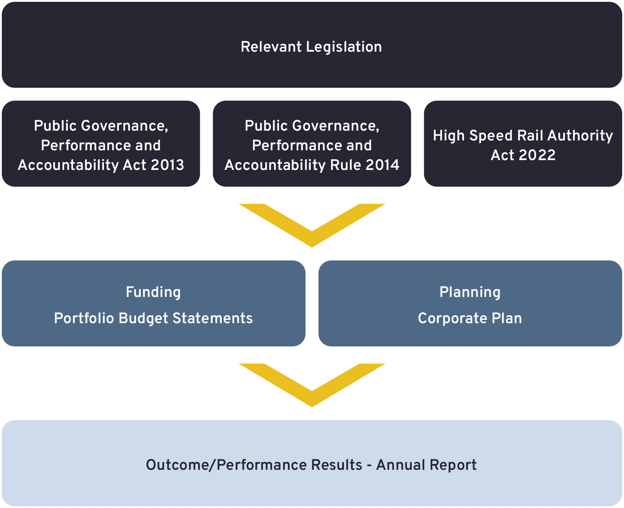

# Section 3 Governance and accountability



## Corporate governance

The Authority was established on 12 June 2023, as a Corporate Commonwealth Entity within the Department of Infrastructure, Transport, Regional Development, Communications and the Arts (the Department). The Authority’s responsible Minister is the Honourable Catherine King MP, Minister for Infrastructure, Transport, Regional Development and Local Government.

The Authority is guided by its corporate governance framework, which ensures that all decisions and actions align with established rules, practices and ethical standards. This framework comprises the Authority’s enabling legislation, the High Speed Rail Authority Act 2022 (HSRA Act) and other legislative instruments, managerial and organisational structures, corporate policies and strategies, and resource management practices.

Throughout this period, the Authority continued to adhere to its statutory obligations and strategic and operational functions guided by the HSRA Act and other Commonwealth guiding legislation, such as the Public Governance, Performance and Accountability Act 2013 (PGPA Act). The PGPA Act establishes a system of governance and accountability for public resources, with an emphasis on planning, performance and reporting. It requires the Authority’s Board, as the accountable authority, to prepare and give an annual report on activities for the period to the Authority’s responsible Minister, for presentation to the parliament. The annual report must comply with the requirements of the Public Governance, Performance and Accountability Rule 2014 (the PGPA Rule). In addition, the Public Service Act 1999 covers the powers of the Chief Executive Officer in relation to the management of human resources.

The Authority recognises the importance of its relationship with the Department in enabling and supporting our successful delivery of the Australian Government’s high speed rail network. The Authority maintains a close working relationship with the Department with respect to the responsibilities of the Authority and for the provision of shared services through a memorandum of understanding (MOU) arrangement.

### Purpose and functions

The Authority’s purpose as per the 2023–24 Corporate Plan is to:

Develop a high speed rail network between cities and key regional centres through policy development and planning, national coordination and strategic advice to enhance Australia’s long term rail investment

The functions of the Authority are specified in sections 8 of the HSRA Act. These are:

1. 1. To:
      1. lead and coordinate policy development and planning; and
      2. consult, liaise and negotiate with States and Territories and other relevant parties; and
      3. provide advice and recommendations to the Minister and other relevant parties (including advice and recommendations on environmental matters and interconnectedness); and
      4. undertake evaluations and research and gather information in relation to the high speed rail network, the high speed rail corridor, a faster rail network and additional rail corridors for a faster rail network;
   2. if the Commonwealth obtains a State’s consent, in accordance with paragraph 51(xxxiv) of the Constitution, to the construction or extension of a railway in the State for the high speed rail network or a faster rail network—to construct or extend the railway in the State for that network;
   3. if the Commonwealth obtains a Territory’s consent to the construction or extension of a railway in the Territory for the high speed rail network or a faster rail network—to construct or extend the railway in the Territory for that network;
   4. any other functions conferred on the Authority by this Act or any other Commonwealth law;
   5. any other functions that are prescribed by rules made for the purposes of this paragraph;
   6. to do anything incidental to, or conducive to, the performance of the above functions.
2. Rules made for the purposes of paragraph (1)(e) must specify the legislative power or powers of the Parliament in respect of each function of the Authority that is prescribed.

### Statement of Expectations

The Authority’s Statement of Expectations applicable to this reporting period was issued by the responsible Minister on 4 August 2023.

The Statement of Expectations provides guidance on the Australian Government’s expectations for the Authority.

### Statement of Intent

The Authority responded to the Statement of Expectations with a Statement of Intent on 29 August 2023. The Statement of Intent outlines the Authority’s roles, responsibilities, statutory functions and accountability obligations under the HSRA Act, the PGPA Act and associated regulations, as well as other relevant legislation and legal instruments.

Both the Statement of Expectations and Statement of Intent can be found on the Authority’s website: [www.hsra.gov.au](http://www.hsra.gov.au).

## Board and committees

### Board

The Authority’s Board is the accountable authority and was established by Division 2, Section 13 of the HSRA Act. Section 14 of the HSRA Act assigns to the Board the following functions: (1) (a) to decide, within the scope of any directions given to the Authority under section 11, the strategies and policies to be followed by the Authority; and (b) to ensure the proper, efficient and effective performance of the Authority’s functions; and (c) any other functions conferred on the Board by this Act. (2) The Board has power to do all things necessary or convenient to be done for or in connection with the performance of its functions.

The Board comprises the following members:

#### Jill Rossouw

#### Ms Jill Rossouw

Board Chair Non‑executive member

Term: 12 June 2023 to 11 June 2026

Ms Rossouw is the first chair of the High Speed Rail Authority and was appointed in June 2023. Jill is an accomplished Non-Executive Director, with multi-sector Board experience across privatised transport infrastructure entities, social infrastructure and public healthcare. She is currently Executive Director, Infrastructure at IFM Investors and a Board member and Chair of the Audit and Risk Committee of the Port of Brisbane. She is a Graduate of Australian Institute of Company Directors and holds a Bachelor of Commerce (University of KwaZulu Natal) and Master of Philosophy in Finance (University of Cambridge, UK).

#### Gillian Brown

#### Ms Gillian Brown

Non-executive member

Term: 12 June 2023 to 11 June 2026

Ms Brown is an experienced Non‑Executive Director with expertise in transport, infrastructure and funds management. She is currently a non‑executive director of Suncorp Group Limited and related entities, Electricity Retained Interest Corporation – Ausgrid Limited and the Ausgrid partnerships, BRIC Housing Limited and Queensland Investment Corporation and related entities. She has an LLB (Hons) from the University of Queensland, a Graduate Diploma in Applied Finance and Investment from FINSIA and is a member of the Australian Institute of Company Directors.

#### Ian Hunt

#### Mr Ian Hunt

Non-executive member

Term: 12 June 2023 to 11 June 2026

Mr Hunt is a former infrastructure CEO with over 40 years’ experience in engineering and project management. His business management experience includes leadership of major project delivery and engineering services organisations and he was CEO of Moorebank Intermodal Company, a Commonwealth government business enterprise. Mr Hunt is currently an independent member of the Canberra Light Rail advisory Board and Non‑Executive Director of the Royal Melbourne Showgrounds.

#### Dyan Perry

#### Ms Dyan Perry OBE

Non-executive member

Term: 12 June 2023 to 11 June 2026

Ms Perry OBE was most recently CEO of High Speed One (HS1) Ltd, responsible for owning, operating and maintaining the HS1 high‑speed railway in the United Kingdom (UK). She has extensive Board experience, has a Masters in Transport and Logistics from Salford University and is a Fellow of the Institute of Leadership and Management.

#### Neil Scales

#### Mr Neil Scales OBE

Non-executive member

Term: 12 June 2023 to 11 June 2026

Mr Scales OBE is an experienced infrastructure leader and was most recently the Director‑General of the Queensland Department of Transport and Main Roads. He was formerly the CEO of Translink and the Director-General of Merseytravel in the UK. He is a Board Member of Queensland PCYC, vice Chair of the National Transport Research Organisation, BAMA Services and a member of the Queensland Transport and Logistics Council.

### Audit and Risk Committee

In accordance with section 45 of the PGPA Act and section 17 of the PGPA Rule the Authority’s Board established an Audit and Risk Committee (ARC). The purpose of the ARC is to oversee the integrity of financial reporting, ensure effective risk management and monitor internal controls within the Authority.

The Authority’s Audit and Risk Committee charter is published on its website at <https://www.hsra.gov.au/accountability-reporting/audit-and-risk-committee-charter>.

The qualifications, knowledge, skills and experience of each member of the ARC are outlined above under Board members. ARC members do not receive remuneration in addition to Board member remuneration.

### People and Culture Committee

The People and Culture Committee (PCC) is a committee established to assist the Authority’s Board fulfil its responsibilities. The functions of the PCC are to periodically review and monitor the appropriateness of the Authority’s:

* Organisation structure and design, including senior appointments
* Remuneration strategies and practices
* Policies and programs to optimise the contribution of the Authority’s employees to support and further the Authority’s Corporate Plan objectives
* Organisational values, culture, and employee engagement.

### Business Case Committee

The Business Case Committee (BCC) is a committee established to provide strategic input into the development of the High Speed Rail Project Definition and Business Case, taking into consideration the Authority’s strategic risks. The BCC also progressively considers the Authority’s management advice on key aspects of the High Speed Rail Project Definition and the Business Case, including making recommendations to the Board in relation to matters that require Board approval.

Table 1.1 Meeting attendance

| Directors | Board | Audit and Risk Committee (ARC) | People and Culture Committee (PCC) | Business Case Committee (BCC) |
| --- | --- | --- | --- | --- |
| Jill Rossouw | 16 [16] | - | 2 [2] | 2 [2] |
| Gillian Brown1 | 16 [16] | 4 [4] | - | 2 [2] |
| Ian Hunt1 | 16 [16] | 4 [4] | 2 [2] | 2 [2] |
| Dyan Perry | 15 [16] | - | 2 [2] | 2 [2] |
| Neil Scales1 | 16 [16] | 4 [4] | 2 [2] | 2 [2] |

1 Audit Committee appointed member – $0 remuneration paid – PGPA Rule Section 17BE(taa)

[ ] number of meetings eligible to attend

### Induction and performance review processes for members of the accountable authority

Upon establishment of the Authority, the Board as accountable authority undertook an information session with the Department of Finance to understand their role and responsibilities under the PGPA Act. The Authority also conducted five deep dive sessions with the Board, to discuss various topics in detail and understand their views.

In March 2024, the Board undertook a Board effectiveness assessment that was facilitated by an independent provider. During this assessment the provider undertook a Board and management effectiveness survey and observed the Board in a Board meeting environment to obtain perspectives on areas for improvement and Board development opportunities. The provider briefed the Board on the findings and observations.

On an ongoing basis, the Board reviews its own performance at Board meetings. The Board undertakes a self-assessment of its performance against the Board Charter of the effectiveness of the Board as a whole, the Chair and individual Board members annually or as required.

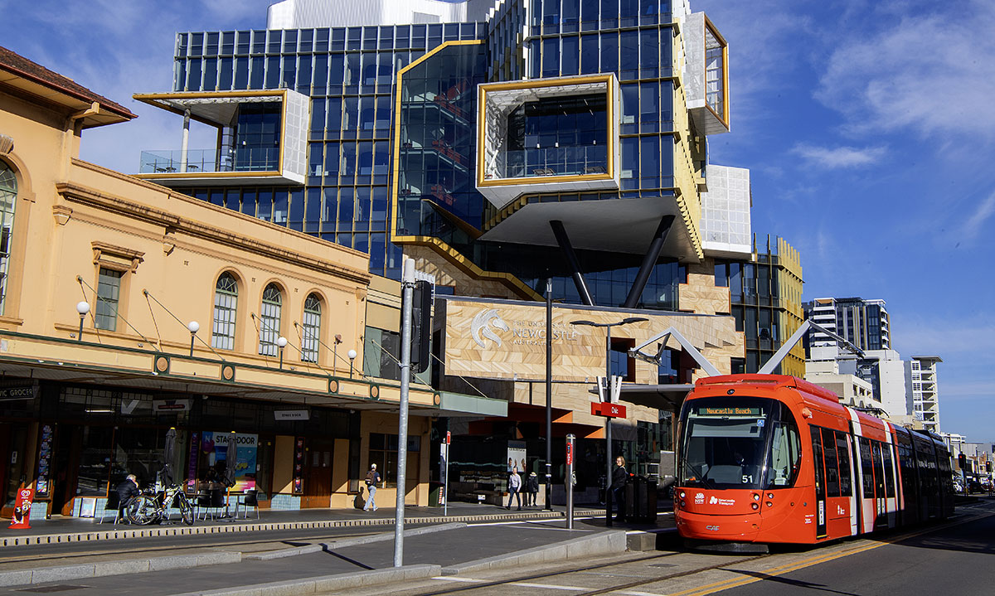

## Other legislative reporting requirements

### Freedom of Information

The Freedom of Information Act 1982 (FOI Act) requires the Authority to publish information as part of the Information Publication Scheme (IPS).

In 2023–24, the Authority received 15 requests for access to documents under the FOI Act. Information about documents to which access is granted is published on the Authority’s Disclosure Log, in accordance with s11C of the FOI Act: <https://www.hsra.gov.au/accountability-reporting/freedom-information>.

### Privacy

In 2023–24, the Authority collected, used, disclosed, stored and disposed of personal information in accordance with the Australian Privacy Principles. No data breaches were identified or reported.

### Risk Management Framework

To achieve its objectives and goals, the Authority has established a comprehensive risk mitigation and assurance process to protect against potential threats and uncertainties.

Key elements of the Risk Management Framework are:

* **Risk management systems and resources** – The Authority’s risk management policies, procedures, tools and templates, together with our resourcing strategy, have been developed to ensure best practice risk management. The Risk Management Framework, facilitated by our in-house and external specialist resources, establishes a systematic approach to risk management, thereby supporting consistency, accountability, compliance and transparency.
* **Comprehensive risk assessment** – The Authority has implemented a comprehensive process for the identification, assessment and management of risks with the potential to impact the achievement of strategic, operational and project objectives. In addition, the Authority also seeks to incorporate lessons learned and continual improvement mechanisms in order to leverage the experience and expertise that exists within other relevant federal and state government agencies and international organisations and projects.
* **Executive decision-making** – Executives and senior management are responsible for making risk informed key decisions at enterprise and project level. The Authority’s decision-making is underpinned by defined risk appetite and tolerance levels, appropriate allocation of resources, clear risk escalation and reporting requirements, and approval processes for risk management strategies to address identified threats and opportunities.
* **Committee oversight** – The Audit and Risk Committee plays a key role in the effective operation of the Authority’s risk management framework. It provides oversight, evaluates risks against appetite, and ensures alignment with strategic goals. Through regular reviews it will identify and assess risks to enhance mitigation measures. Additionally, the Committee fosters transparency and accountability, promoting open risk communication.
* **Internal audit processes** – The Authority procured internal audit services to provide important key risk and critical controls assurance by planning and performing regular and ad-hoc audits of the Authority’s operations to enhance risk mitigation, strengthen internal controls, confirm compliance, and drive operation efficiency.
* **Risk culture** – The Authority risk management culture focuses on embedding risk management into our daily business activities and processes. Key strategies include:
  + The Authority’s Board regularly considers the impact of risks
  + The Authority’s Board uses the risk appetite and tolerance to underpin the risk culture
  + Risk management is supported by robust governance and clear accountability
  + The Authority’s executive exemplifies positive risk behaviour by consistently demonstrating it in their actions
  + Decision makers ask questions about risks and seek more information (as required)
  + Risk management arrangements are clearly communicated throughout the entity
  + Business case and policy proposals include consideration of risk, not just benefits
  + Resource allocation is informed by risk
  + Staff are part of risk workshops and participate in relevant training.

### Fraud control

In accordance with section 10 of the PGPA Rule, the Authority produced a Fraud Corruption and Control Plan and Fraud Risk Register. The plan detailed the Authority’s strategic and operational approaches to controlling fraud and corruption, comprising a range of prevention, detection, investigation, recovery and reporting measures. The Authority’s approach to identifying and controlling fraud and corruption risks aligned with the Authority’s Risk Management Policy and Framework.

The Fraud Risk Plan and Register will be reviewed annually and a fraud risk assessment undertaken biennially.

During 2023–24, there were no instances of fraud or potential fraud detected.

### Indemnities and insurance

During 2023–24 the Authority held insurance arrangements through Comcover for general liability, professional indemnity, directors’ and officers’ liability, and a range of other corporate insurance. In addition, the Authority held workers compensation cover through Comcare.

### Internal audit

The Authority has a two-year internal Audit Plan, which is designed to identify risk, ensure compliance and improve operational efficiency on a rolling basis. The Plan is agreed and updated annually in consultation with the Authority’s internal audit provider, the Executive and the Audit and Risk Committee.

The focus for 2023–24 was to assess the establishment process and governance structure of the Authority.

### External audit

The Australian National Audit Office is responsible for auditing the Authority’s financial statements.

### Commonwealth Electoral Act 1918

The Authority did not procure market research and advertising services during the 2023–24 period.

### Transactions with related entities

The Authority’s MOU for property and corporate services with the Department includes subleasing the Authority’s Canberra premises at 62 Northbourne Avenue as well as being provided with corporate service functions including; ICT, payroll and financial processing. Under this MOU there were 12 transactions in reporting period 2023–24 totalling in aggregate of $356,551 (GST exempt).

As a prescribed entity, the Authority follows the Commonwealth Procurement Rules and has a system of delegated authorisations for procurement. The Authority’s Board, as the accountable authority, approves an annual budget for the Authority. Expenditure of over $1 million, must be approved by the Board. For transactions up to $1 million, the CEO will approve the transactions, with reduced delegations provided to other management staff. All related entity transactions are authorised by management in accordance with the Commonwealth Procurement Rules and relevant delegations.

### Judicial decisions and reviews by outside bodies

There were no judicial decisions of which the Authority was aware that affected the Authority during the reporting period.

The Office of the Australian Information Commissioner reviewed a decision made by the Authority under section 44A of the Public Interest Disclosure Act 2013 and affirmed the Authority’s decision on 9 May 2024.

### Ministerial directions and government policy orders

The portfolio Minister may give written directions of a general nature to the Authority about the performance of its functions in accordance with Division 3, section 11 of the HSRA Act.

The Authority was not subject to any ministerial directions or government policy orders during the reporting period.

### Environment Protection and Biodiversity Conservation Act 1999

As required under section 516A of the [Environment Protection and Biodiversity Conservation Act 1999](https://www.legislation.gov.au/Series/C2004A00485), the Authority is committed to implementing ecologically sustainable practices in its operations. In 2023–24, the Authority was co‑located with the Department which provided accommodation and property services, including monitoring of its environmental performance and supporting ecologically sustainable development initiatives such as:

* energy-efficient lighting
* automated lighting controls which switch off non‑essential lighting outside of work hours
* recycling (including secure where needed) of paper, glass, plastic, metal and organic waste — provision of centralised collection points allows for an increased uptake of recycling and organic waste disposal and a reduction in the Department’s environmental footprint.

In addition, the Authority contributed to reducing its environmental impact through initiatives such as:

* reduced air travel through utilising digital technologies where practical for meetings with intrastate and interstate counterparts, and
* minimising paper usage through electronic correspondence and record keeping.

Greenhouse gas emissions reporting has been developed with methodology that is consistent with the Whole-of-Australian Government approach as part of the APS Net Zero 2030 policy. Under a memorandum of understanding (MOU) with the Department for property and corporate services, the Authority has subleased an office space in Canberra from the Department and leveraged the Whole-of-Australian Government contract arrangement for domestic flights. Accordingly, the Authority’s electricity and domestic flight data for reporting period 2023–24 is captured in the Department’s Emissions Source data included in their annual report.

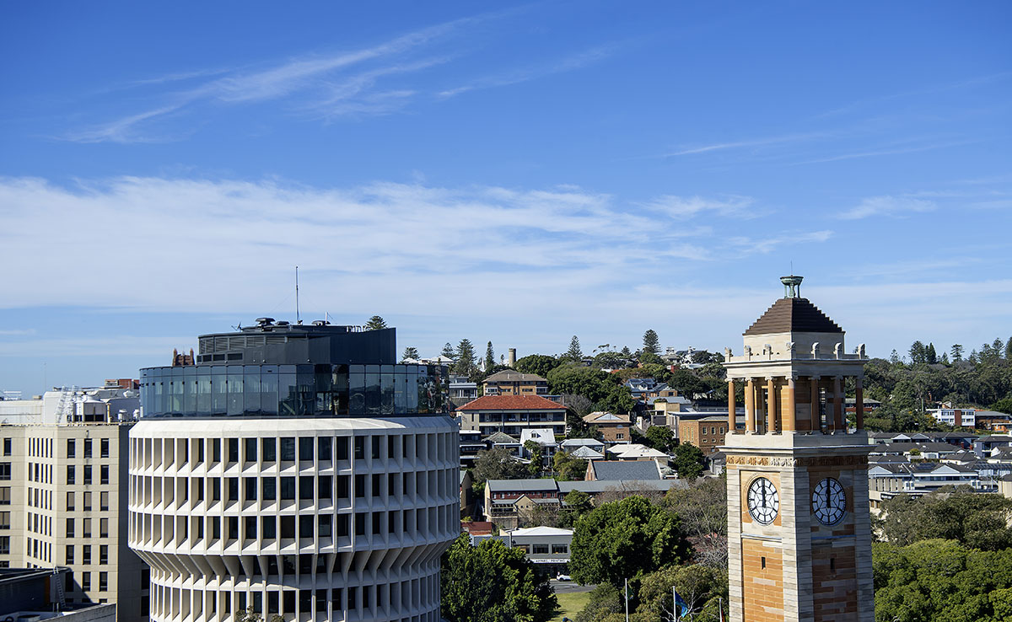

### Commonwealth Child Safe Framework – annual statement of compliance

The Authority was committed to ensuring that its work and activities did not expose children to abuse and harm.

The policy is referenced in the Authority’s Enterprise Risk Register. Given the nature of the work of the Authority, there is generally no interaction with children so the overall risk was deemed as low. However, risk assessments will be conducted annually as well as when assessing activities undertaken or overseen by the Authority, including contracts for services and developing selection criteria for recruitment processes.

In supporting child safety, the Authority will uphold children’s rights by ensuring:

* any risks to children are proactively identified and managed
* all staff undertaking child-related work, including contracted staff, are appropriately screened and comply with relevant legislation
* the National Principles for Child Safe Organisations are adopted and implemented within the Authority’s Risk Management and Policy Framework.

# Section 4 Organisational profile



## Structure and location

The Authority is governed by a Board of five experienced independent members, each bringing experience and expertise in the infrastructure sector.

The executive team consists of highly experienced and highly regarded professionals with diverse industry experience and backgrounds, who are dedicated to advising the Authority towards its strategic objectives. With extensive experience in their respective fields the team members collaborative approach fosters a culture of innovation and excellence. The executive team drives the Authority to achieve its goals and deliver value to our stakeholders.

This structure ensures governance, strategic oversight, and a commitment to our core values. This structure promotes evidence‑based decision-making and fosters transparency, accountability, and integrity across all levels of operations.

### Organisational structure

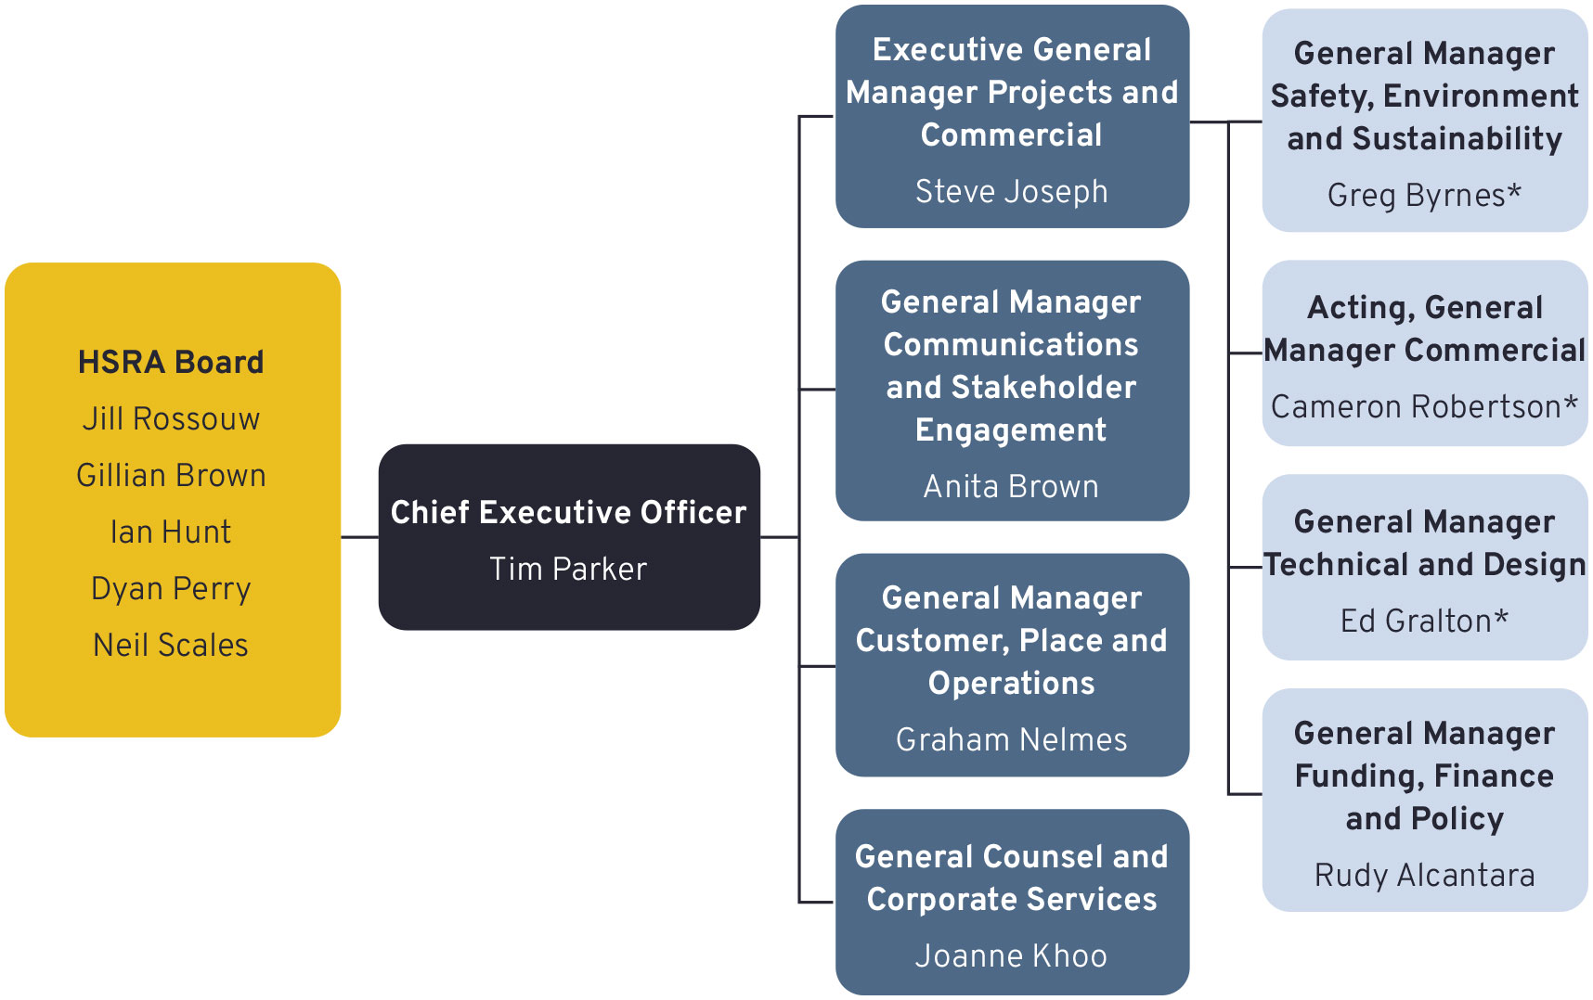

* Executive team members that commenced post–30 June 2024.

### Location

In 2023–24, the Authority was co‑located with the Department which provided accommodation in its 62 Northbourne Avenue, Canberra office and temporary project accommodation in Milsons Point under an agreement with the Transport for NSW agency.

In 2024-25, the Authority has established a corporate office in North Sydney, and a community information centre in Newcastle is being set up.

## Values

HIGH SPEED RAIL AUTHORITY
Safety and wellbeing
We take responsibility to ensure that how we work and what we deliver will be safe. We recognise the importance of wellbeing for our staff and the wider team and will ensure we create a culture where people thrive
Team work and respect
Our people and our culture drive our success. We value diverse perspectives and treat every individual with respect, kindness and consideration. We work together to leverage each other’s strengths, share ideas and overcome challenges, creating a positive and productive work environment
Accountability and integrity
We take responsibility for our actions and honour our commitments. We foster a culture of honesty, transparency and ethical decision‑making to build trust and respectful relationships
Impact and innovation
Our work is meaningful and will make a lasting positive impact for all Australians. We are committed to using our skills and talents to solve problems and create a better and more sustainable future. We promote creative and forward-thinking ideas and solutions
Agile and learning
We are efficient and undertake rapid issue resolution to inform timely decision making. We have an openness to learn, develop and embrace change

## People

### Organisational Strategy

The Authority’s Organisational Strategy was completed on 27 November 2023. The Organisational Strategy outlines recommendations on organisational structure, key staff recruitment activities and staff training and capability development.

The Organisational Strategy along with the Authority’s Strategic Plan informed an analysis of resource requirements and scope of work needed for the Authority to deliver a detailed Business Case for high speed rail on the Sydney to Newcastle section.

### Enterprise bargaining

During the reporting period, the Authority took part in the Australian Public Service wide Enterprise Bargaining. In consultation with its employees and the Community and Public Service Sector Union (CPSU), the Authority negotiated the High Speed Rail Authority Enterprise Agreement 2024–2027 (the Agreement). An application for approval was made in line with s185 of the Fair Work Act 2009 and the Agreement was approved by the Fair Work Commission on 22 April 2024. In accordance with s54 of the Fair Work Act 2009 the Agreement began on 29 April 2024.

### Composition of workforce

As at 30 June 2024, the Authority had a total of 15 ongoing employees and one non‑ongoing employee (excluding the CEO). Of these, 11 employees were located in the Australian Capital Territory, four employees were located in New South Wales and one employee was located in Queensland.

Table 1.2 All ongoing employees as at 30 June 2024 a, b

|  | Man/Male | | | Woman/Female | | | TOTAL |
| --- | --- | --- | --- | --- | --- | --- | --- |
| Full-time | Part-time | Total | Full-time | Part-time | Total |
| **ACT** | 2 | - | **2** | 8 | 1 | **9** | ****11**** |
| **NSW** | 1 | - | **1** | 2 | - | **2** | ****3**** |
| **QLD** | - | - | **-** | 1 | - | **1** | ****1**** |
| ****TOTAL**** | ****3**** | ****-**** | ****3**** | ****11**** | ****1**** | ****12**** | ****15**** |

a Excludes CEO; see Key Management Personnel remuneration table for details.

b As at 30 June 2024, no ongoing employees identified their gender as non‑binary, prefers not to answer or uses a different term.

Table 1.3 All non‑ongoing employees as at 30 June 2024 a, b

|  | Man/Male | | | Woman/Female | | | TOTAL |
| --- | --- | --- | --- | --- | --- | --- | --- |
| Full-time | Part-time | Total | Full-time | Part-time | Total |
| **NSW** | 1 | - | **1** | - | - | **-** | ****1**** |
| ****TOTAL**** | ****1**** | ****-**** | ****1**** | ****-**** | ****-**** | ****-**** | ****1**** |

a Excludes CEO; see Key Management Personnel remuneration table for details.

b As at 30 June 2024, non-ongoing employees identified their gender as non‑binary, prefers not to answer or uses a different term.

### Work Health and Safety

The Authority is committed to providing a safe workplace for all employees and contractors, and complies with Work Health and Safety Act 2011. As part of this commitment, during 2023–24, the Authority:

* developed a work health and safety (WHS) framework, which includes online training
* continued ongoing flexible working from home/office arrangements in consultation with employees
* promoted safety and wellbeing programs delivered by the Department
* attended the Department’s quarterly WHS Committee meetings in an observer capacity
* carried out WHS inspections of the office
* provided employees and contractors with WHS assessments, optical assessments, flu vaccinations and ergonomically appropriate equipment as required
* maintained a hybrid workspace for employees to work from home or in the office, with video-conferencing capability to facilitate regular structured communication via weekly all staff, section and executive video link meetings, as well as other meetings as necessary.

There were no incidents notified to Comcare, no notices received from Comcare, no investigations undertaken, and no active workers’ compensation claims during the reporting period.

### Ethical standards

In 2023–24, the Authority demonstrated a commitment to promoting ethical standards and behaviours within the workplace, which are reflected within the Authority’s Values and the APS Values, Employment Principles and Code of Conduct. Employees completed mandatory Integrity in the APS training and the Authority took reasonable steps to avoid any conflicts of interest through its formal annual process for declaration of interests.

## Executive remuneration

Commonwealth entities are required to disclose information about key management personnel, senior executives and other highly paid staff in their annual reports in accordance with Subdivision C, sections 17CA–17CE of the PGPA Rule.

The Authority’s key management personnel are Holders of Public Office and are the Chair, Board members and Chief Executive Officer. The Chair and Board members’ remuneration and allowances are set by the Remuneration Tribunal’s determination for Holders of Part-time Public Office. The Chief Executive Officer’s remuneration and allowances are set by the corresponding determination for Holders of Full-time Public Office.

During the reporting period the Authority’s senior executive comprised the Executive General Manager Projects and Commercial, General Manager Safety, Environment and Sustainability, General Manager Technical and Design, General Manager Funding, Finance and Policy, General Manager Communications and Stakeholder Engagement, General Manager Customer, Place and Operations and General Counsel and Corporate Services.

The following tables report on the remuneration of the Authority’s key management personnel and senior executive in 2023–24. The Authority did not have any other highly paid staff for this period.

Key management personnel remuneration for the reporting period 2023–24 are detailed at Part 3.2 in the Financial Statements. In accordance with the PGPA Rule, this information is further disaggregated as follows:

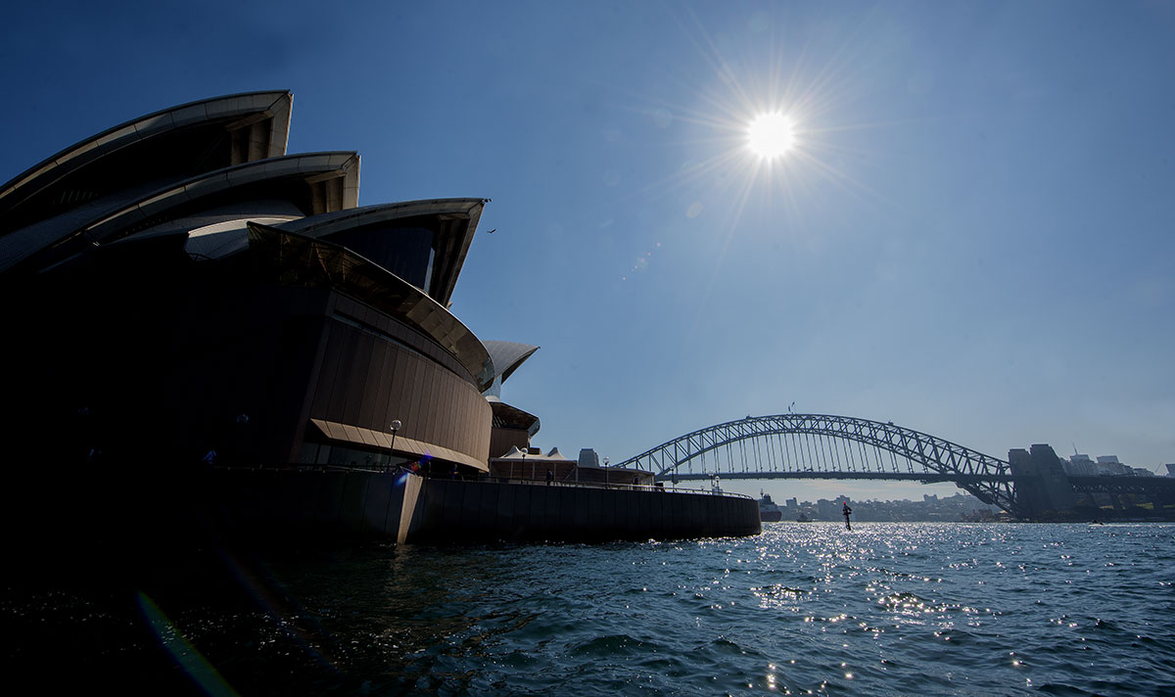

Table 1.4 Information about remuneration for key management personnel

|  | | Short-term benefits | | | Post-employment benefits | Other long-term benefits | | Termination benefits | Total remuneration |
| --- | --- | --- | --- | --- | --- | --- | --- | --- | --- |
| Name | Position title | Base salary | Bonuses | Other benefits and allowances | Superannuation contributions | Long service leave | Other long-term benefits |
| Jill Rossouw | Chair | $130,108 | - | $1,379 | $14,504 | - | - | - | $145,991 |
| Neil Scales* | Board Member | $65,054 | - | $562 | $7,252 | - | - | - | $72,868 |
| Gillian Brown* | Board Member | $65,054 | - | $387 | $7,252 | - | - | - | $72,693 |
| Ian Hunt* | Board Member | $65,054 | - | $504 | $7,005 | - | - | - | $72,563 |
| Dyan Perry | Board Member | $65,054 | - | $362 | - | - | - | - | $65,416 |
| Andrew Hyles | Acting Chief Executive Officer | $127,367 | - | - | $31,196 | - | - | - | $158,563 |
| Tim Parker | Chief Executive Officer | $236,699 | - | $1,489 | $26,384 | $2,433 | - | - | $267,005 |
| ****TOTAL**** |  | ****$754,390**** | ****-**** | ****$4,683**** | ****$93,593**** | ****$2,433**** | ****-**** | ****-**** | ****$855,099**** |

* Audit and Risk Committee members do not receive additional remuneration for serving on the committee.

Table 1.5 Information about remuneration for senior executives

| Total remuneration bands | Number of senior executives | Short-term benefits | | | Post-employment benefits | Other long-term benefits | | Termination benefits | Total remuneration |
| --- | --- | --- | --- | --- | --- | --- | --- | --- | --- |
| Average base salary | Average bonuses | Average other benefits and allowances | Average superannuation contributions | Average long service leave | Average other long-term benefits | Average termination benefits | Average total remuneration |
| $0- $220,000 | 3* | $29,625 | - | - | $2,812 | $309 | - | - | $32,746 |
| $220,001- $245,000 | 1 | 198,040 | - | - | 26,894 | 4,846 | - | - | 229,870 |

* Includes staff who commenced employment towards the end of FY2023–24.

General Manager Customer, Place and Operations first pay fell in the 2024–25 period.

Notes: Remuneration is calculated on an accrual basis and excludes short-term acting arrangements. Short-term benefits include the value of annual leave accrued during the financial year, rather than leave taken. Long-term benefits reflect the value of long service leave accrued during the year, rather than any leave taken. Remuneration for senior executives excludes employees classified as Key Management Personnel in Table 1.3

# Section 5 Financial performance



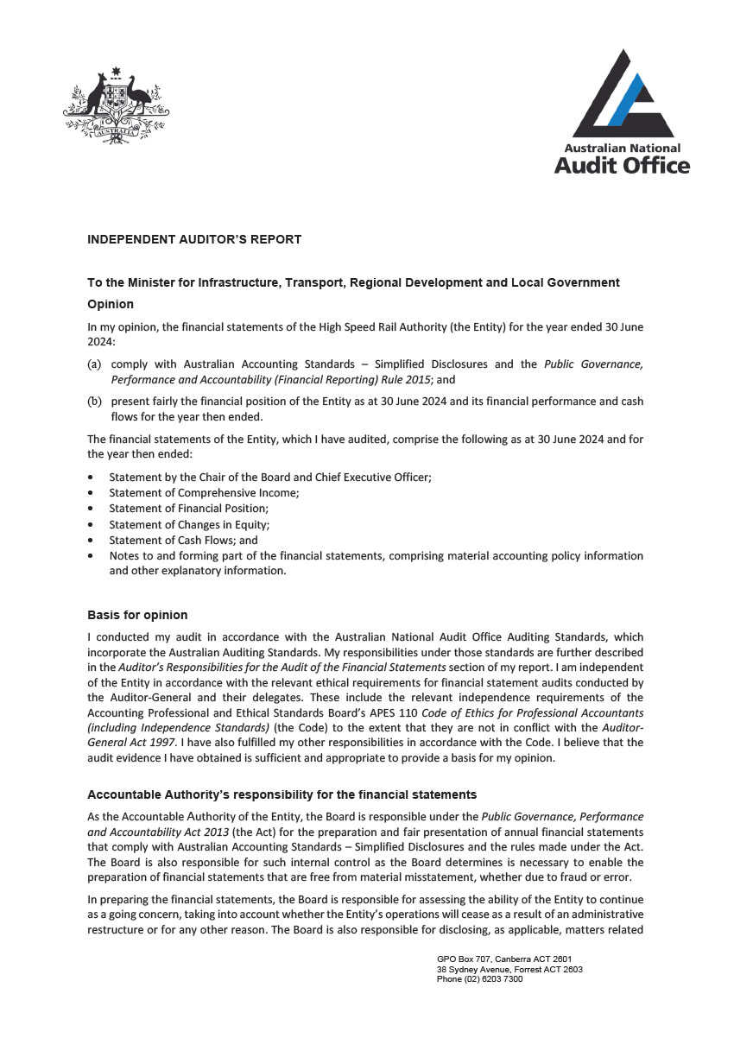

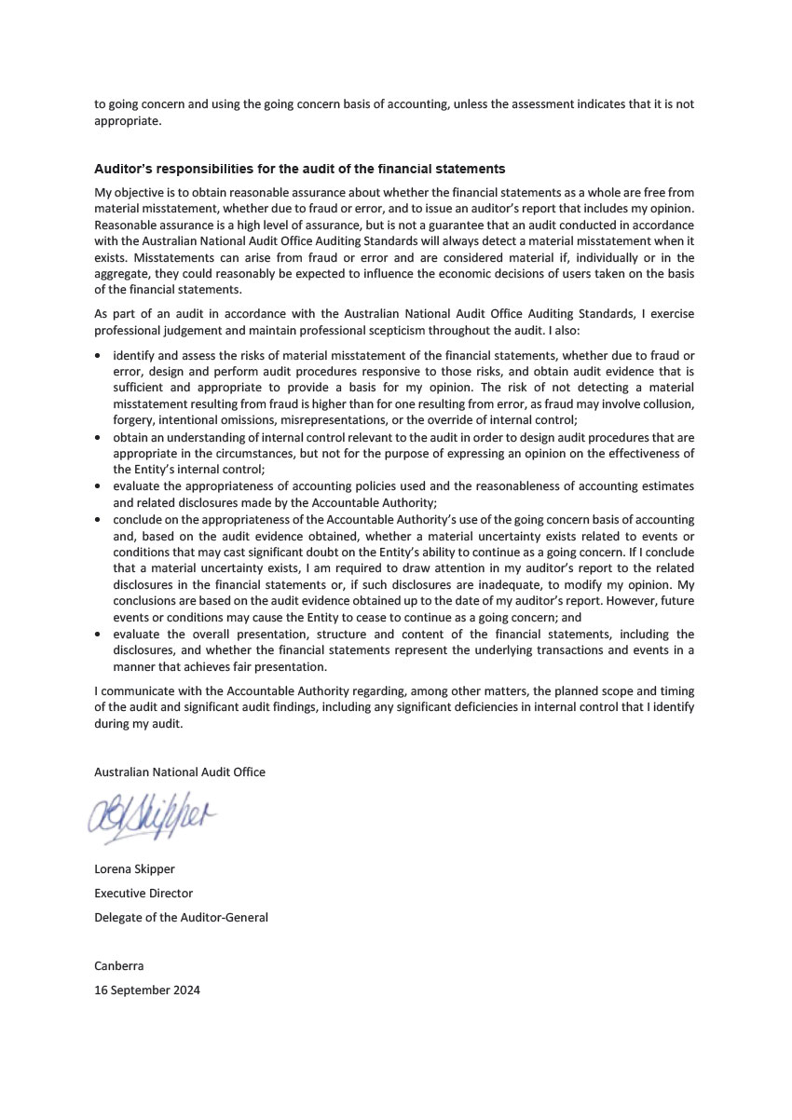

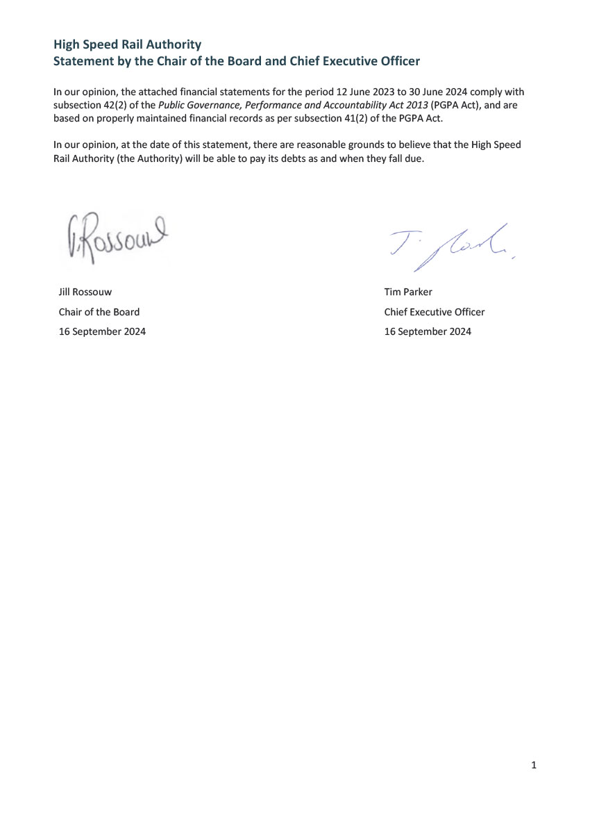

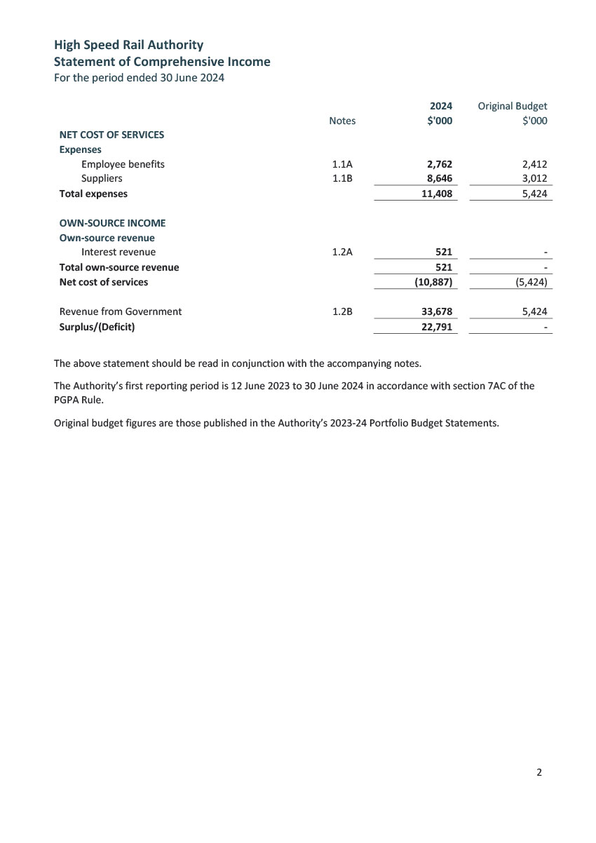

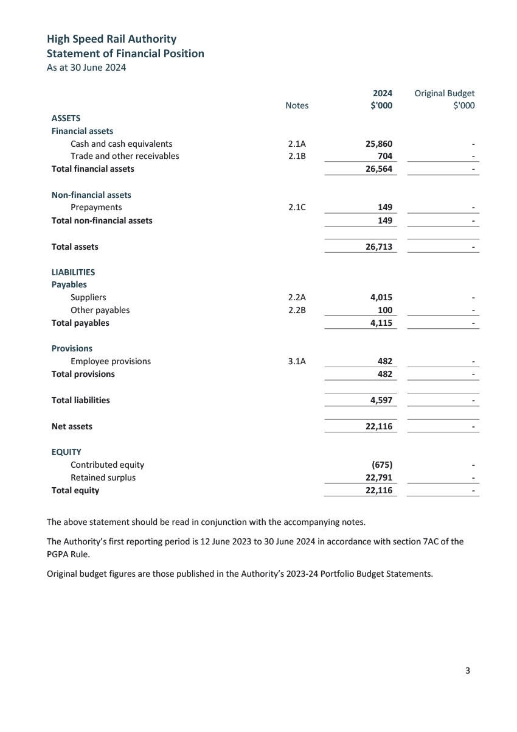

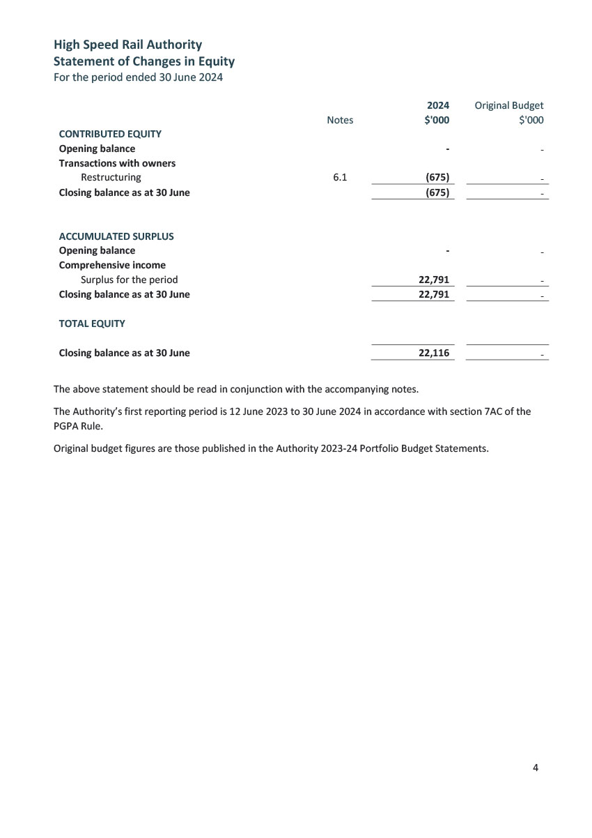

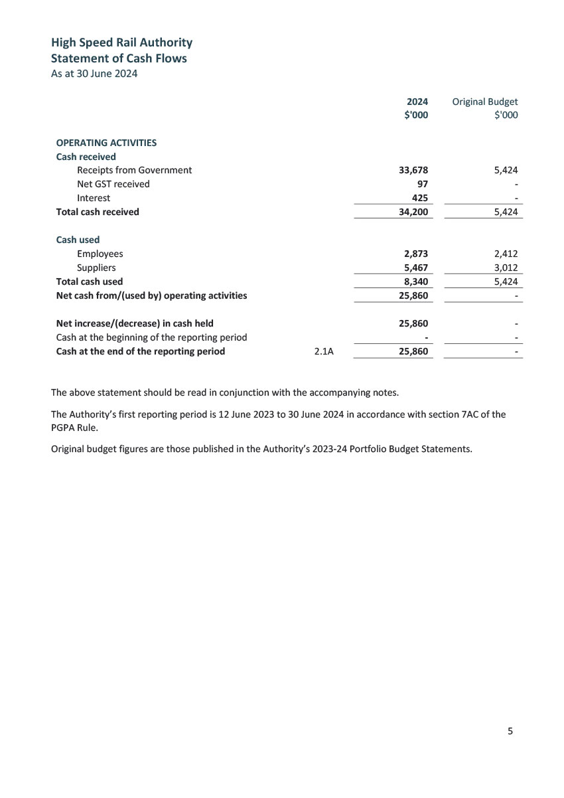

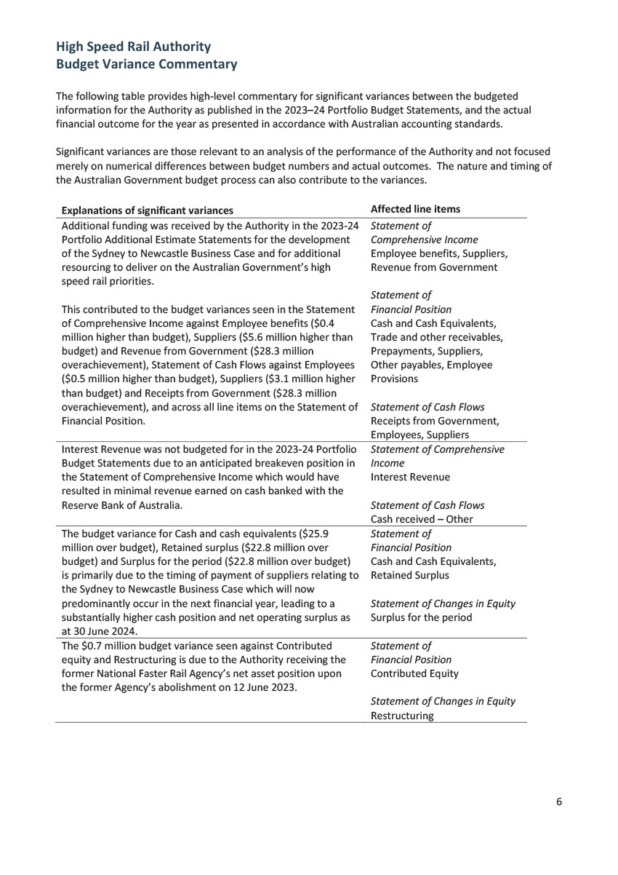

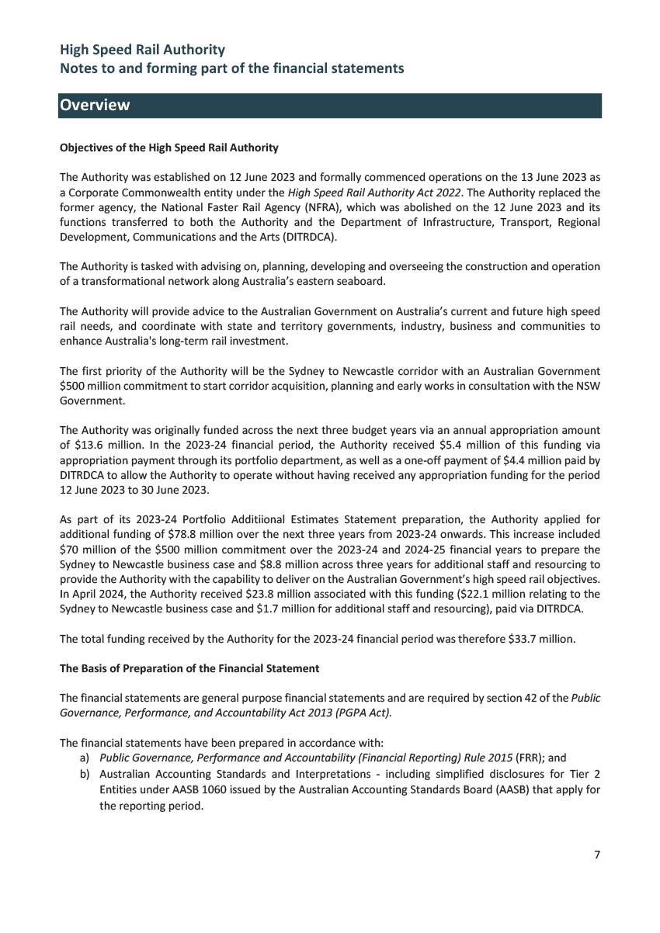

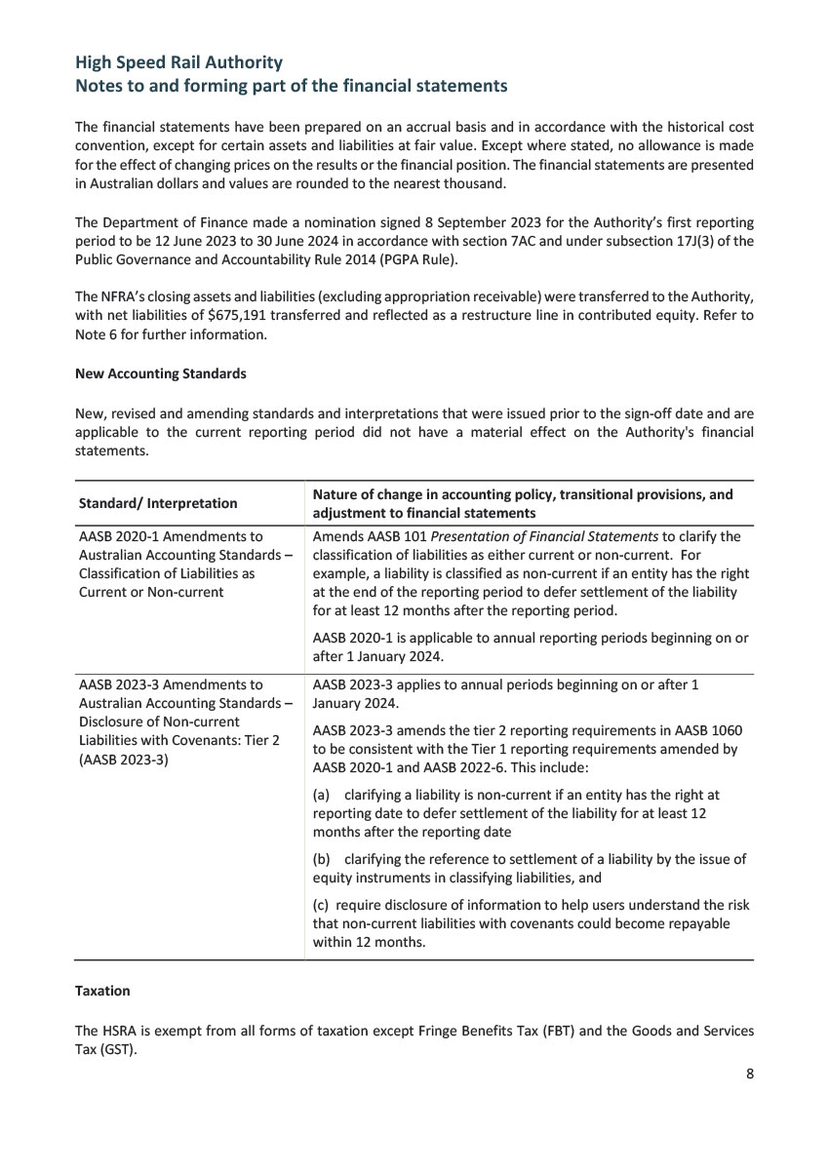

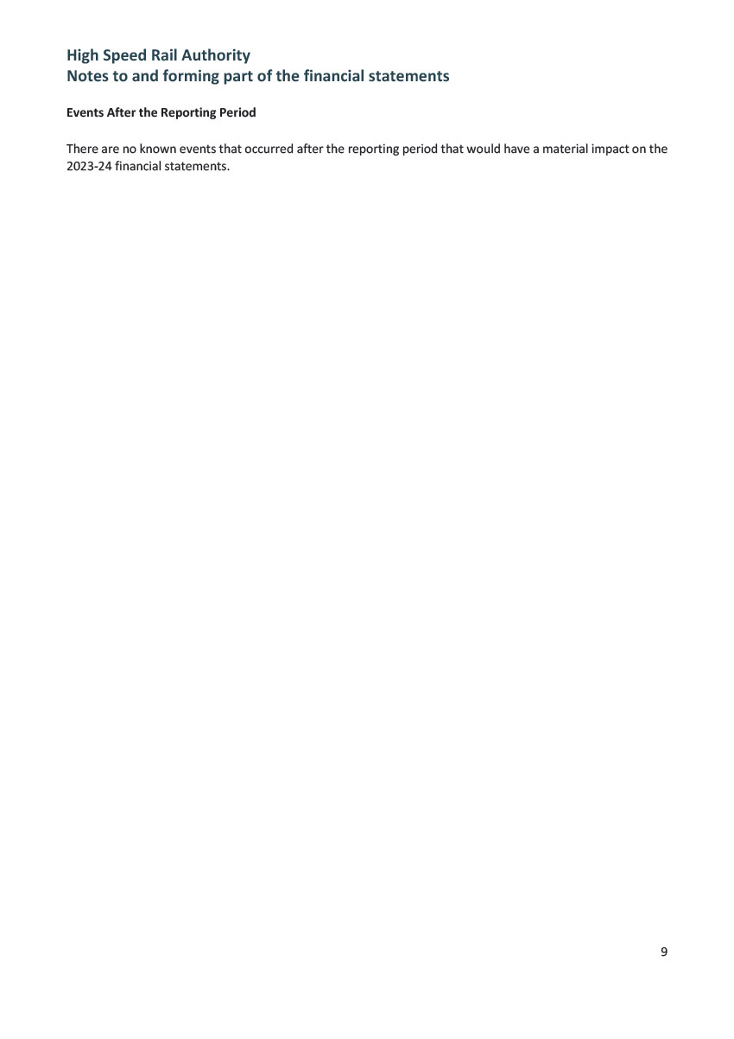

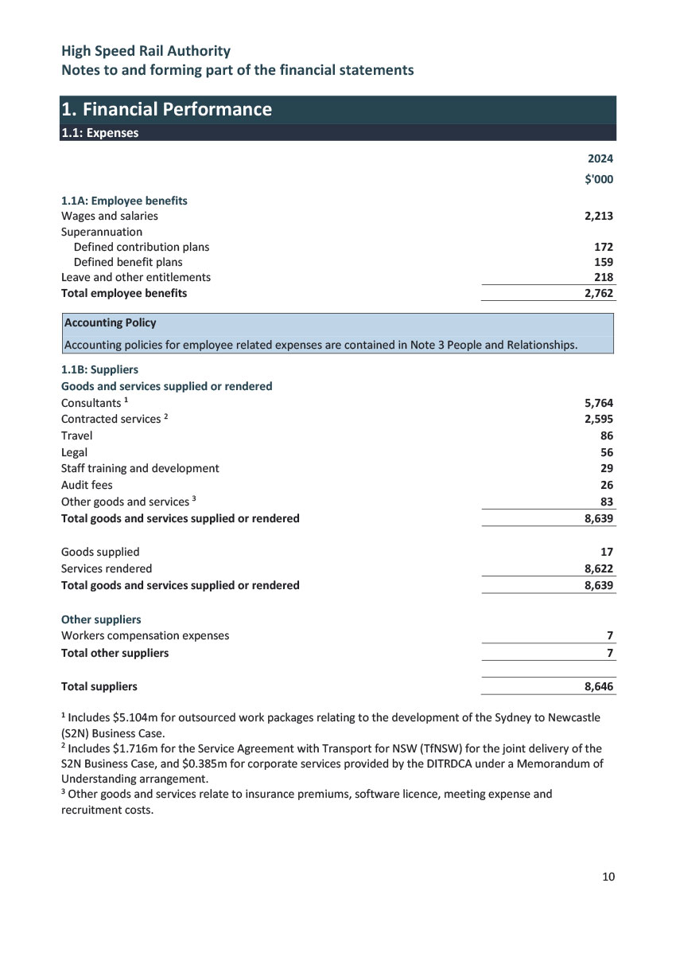

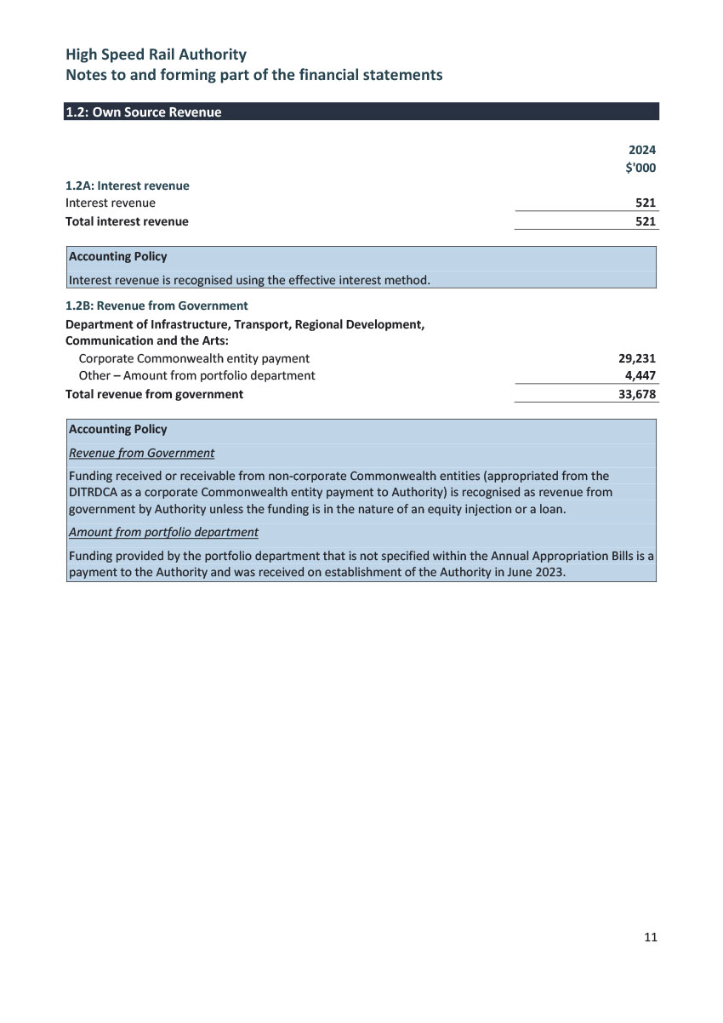

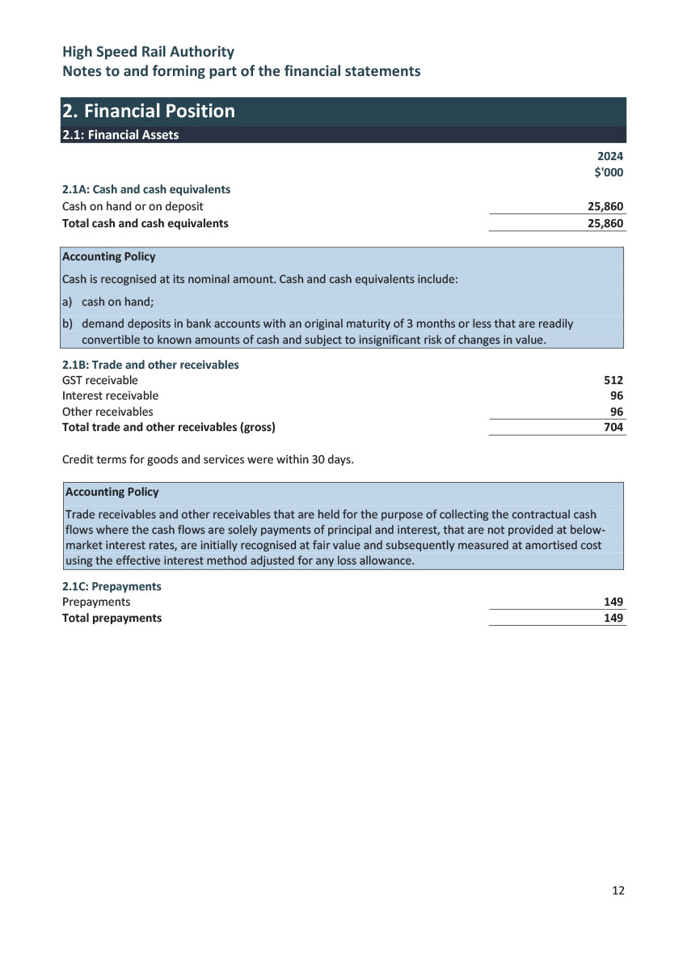

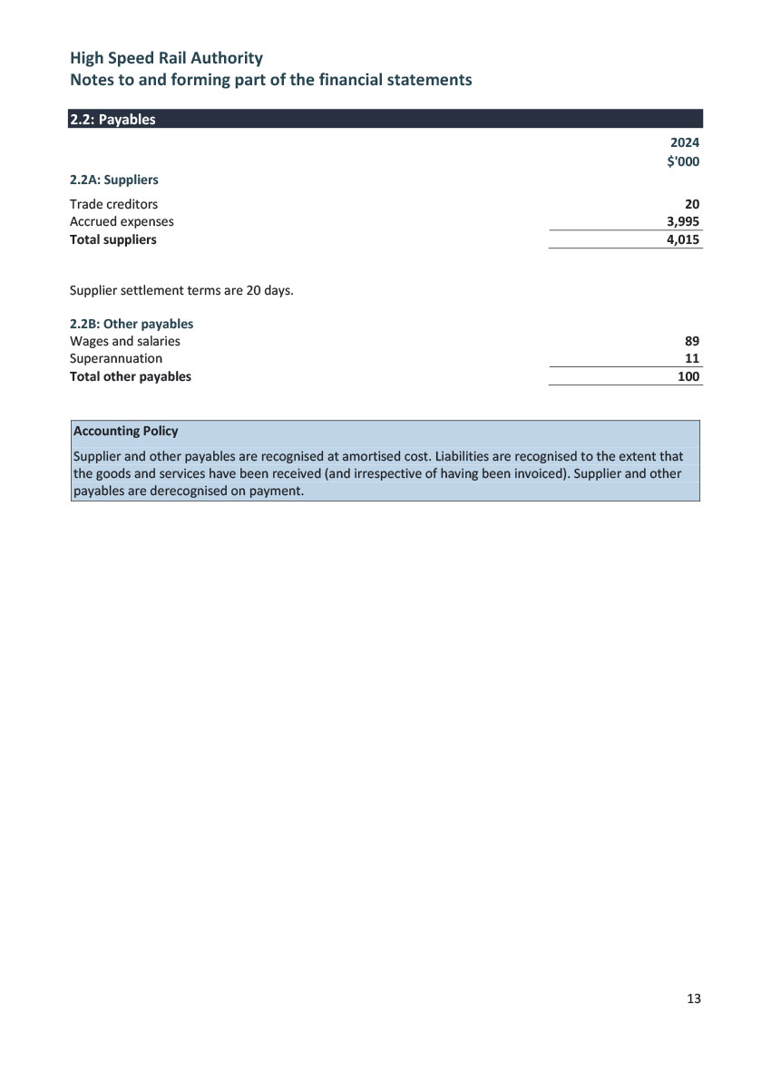

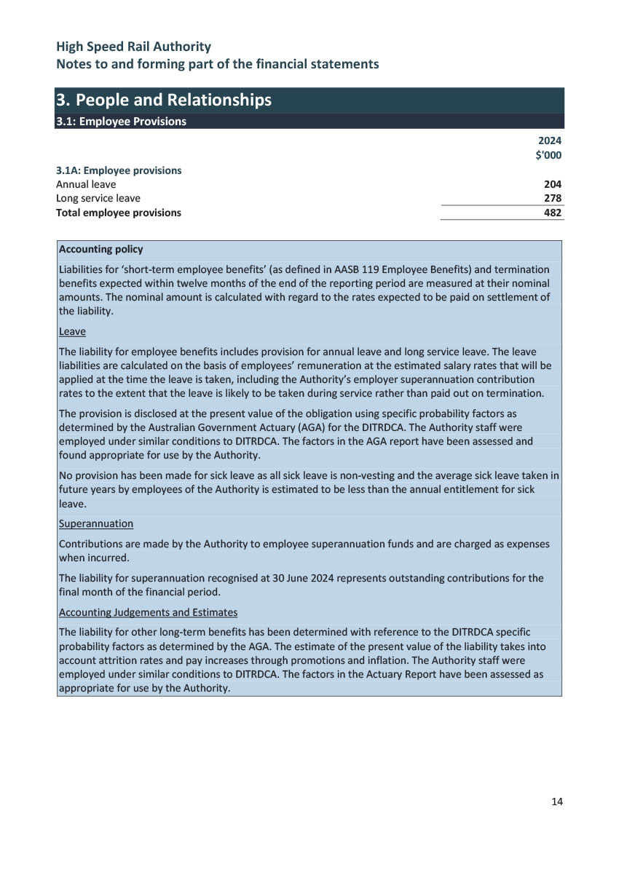

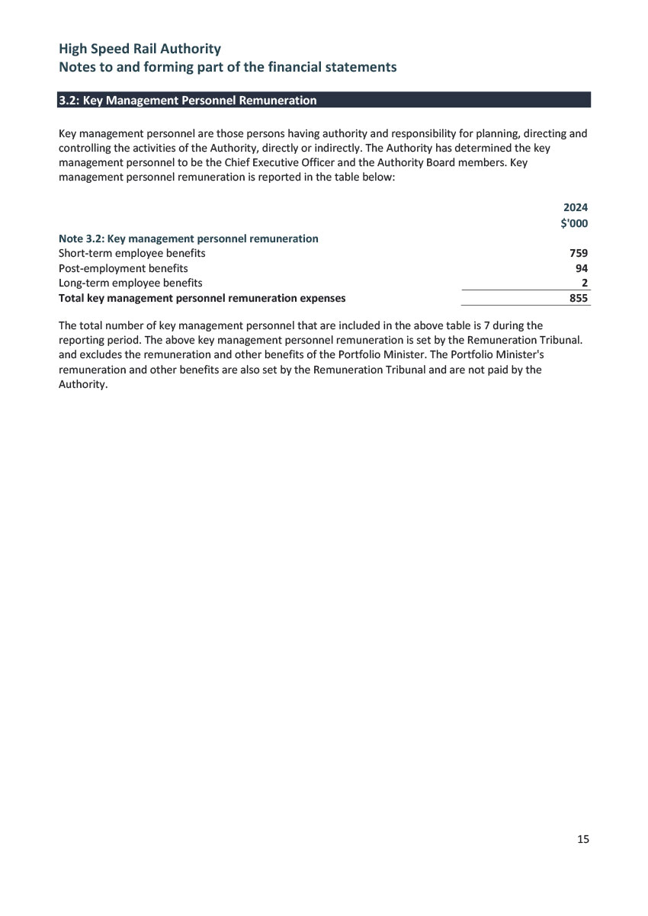

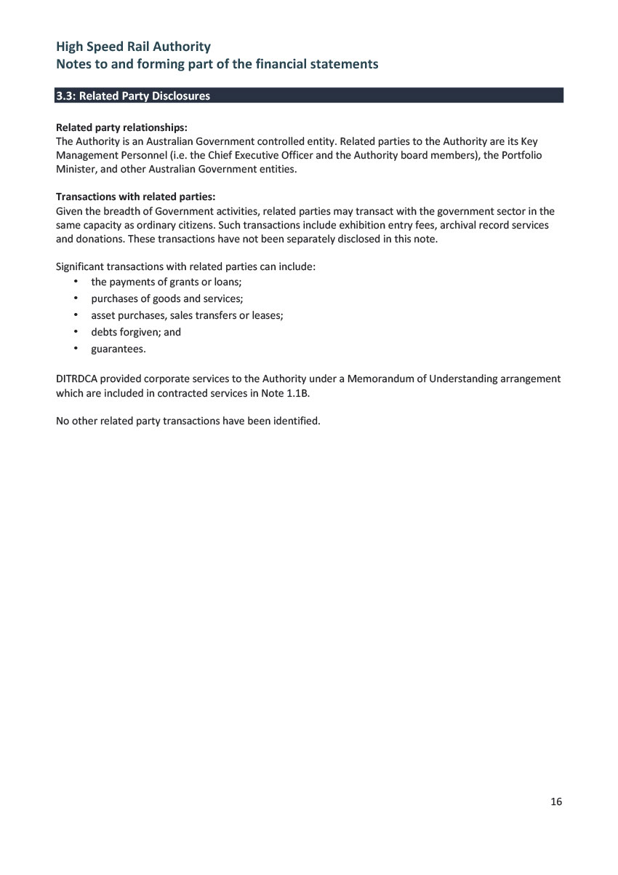

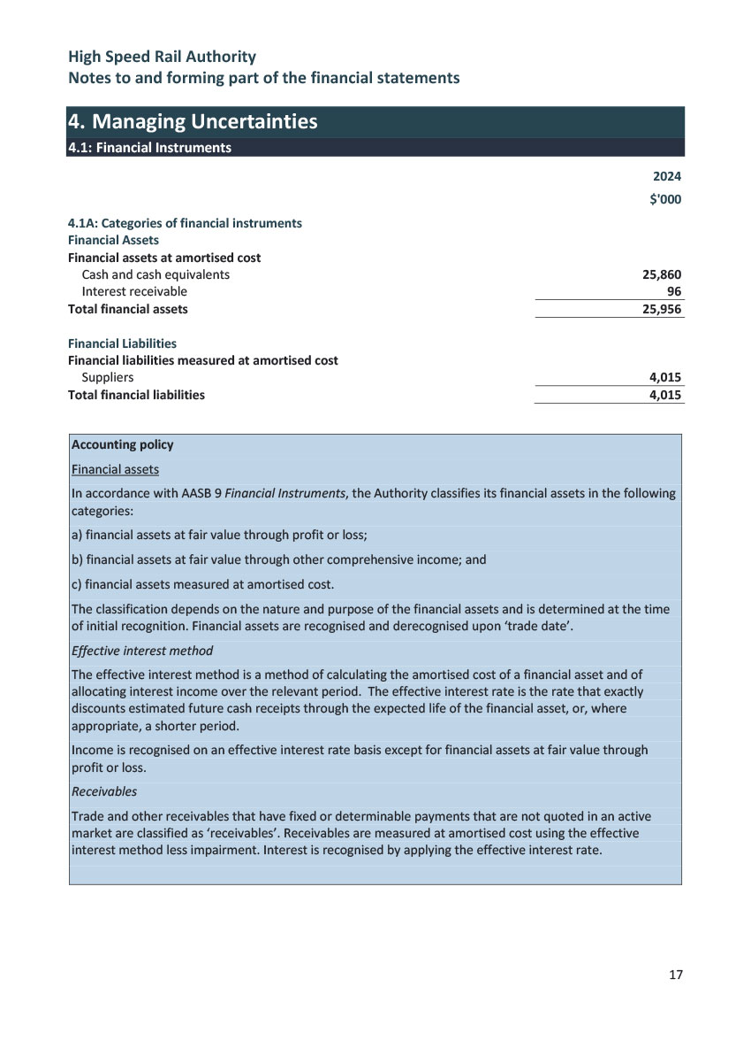

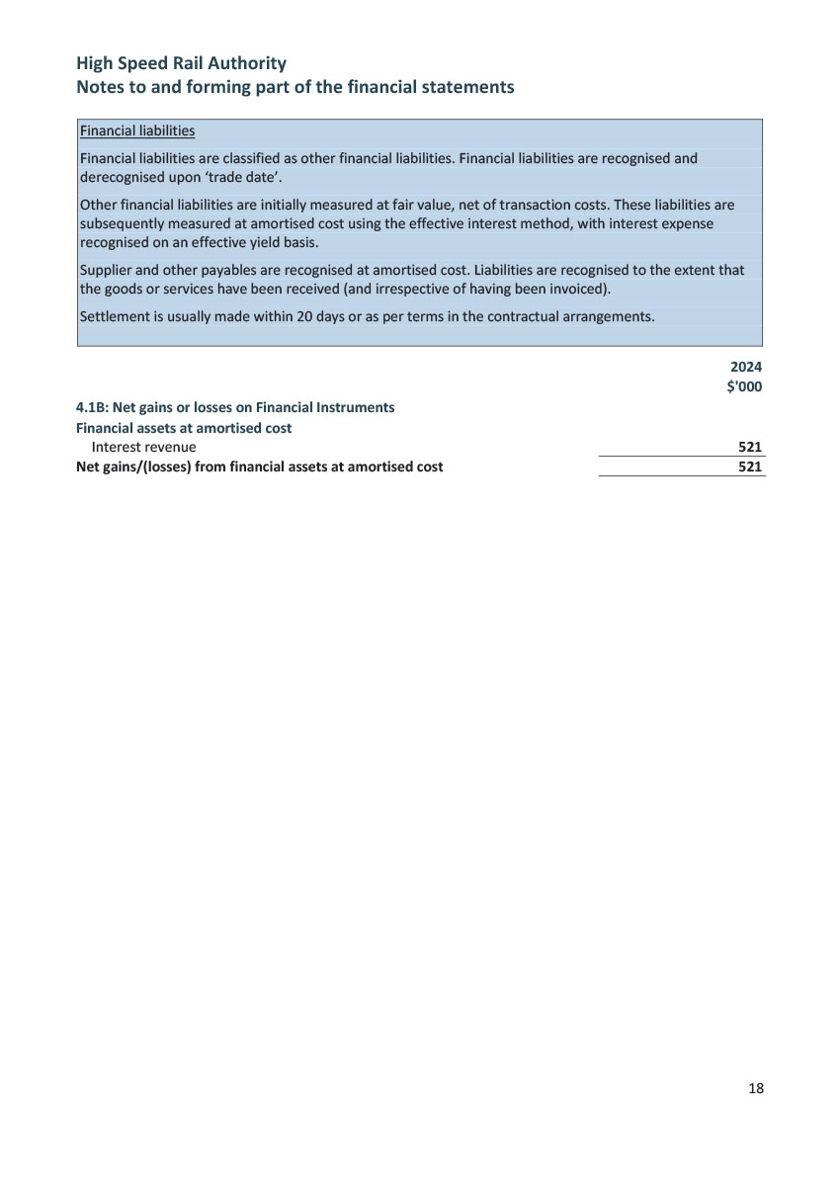

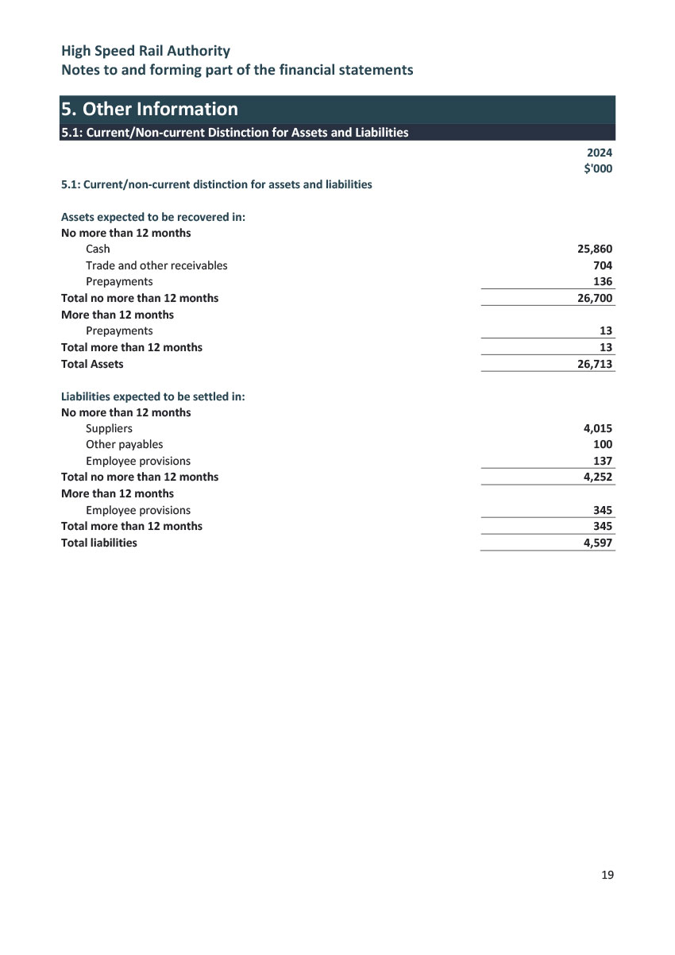

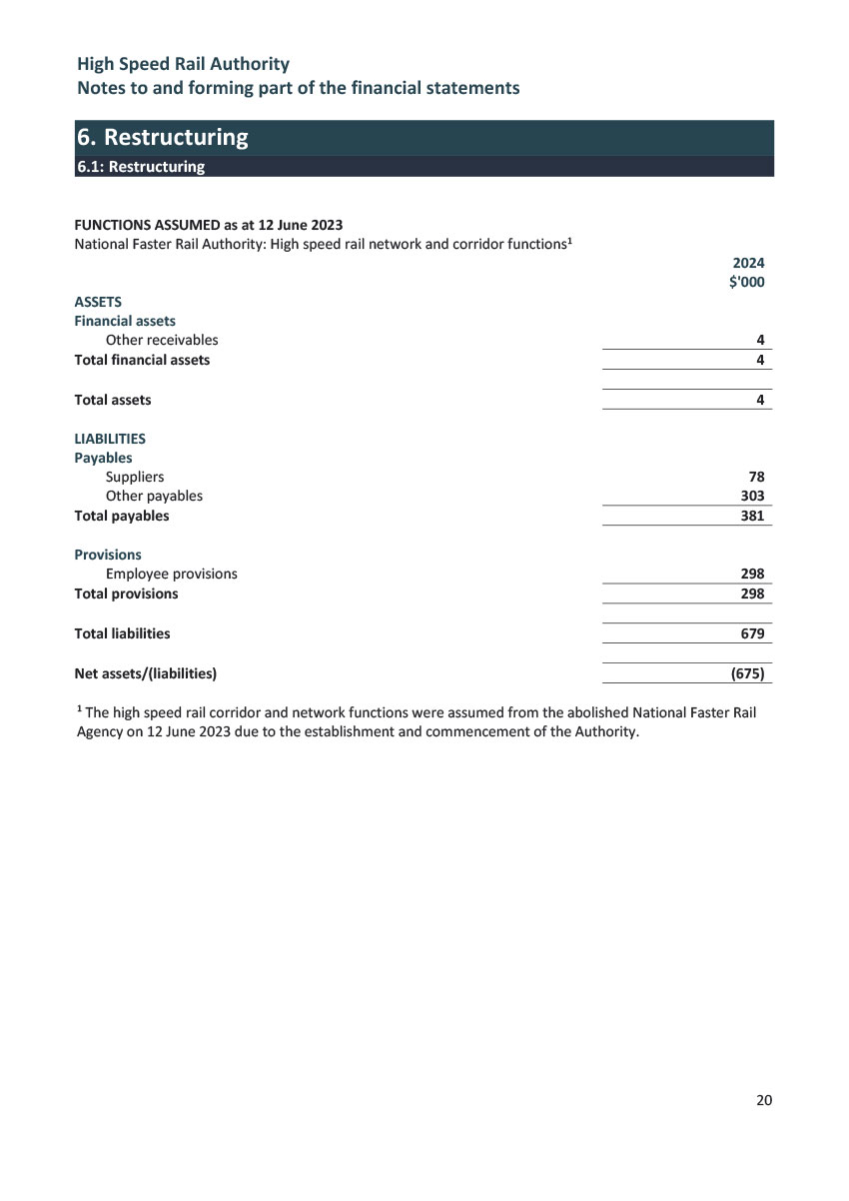

# Section 6 Reference information



## List of annual report requirements

As required under Schedule 2A, Section 17BE(u) of the Public Governance, Performance and Accountability Rule 2014, the table below provides a list of requirements to be included in entities’ annual reports as an aid of access.

| PGPA Rule Reference | Part of Report | Description | Requirement |
| --- | --- | --- | --- |
| 17BE | Contents of Annual Report | |  |
| 17BE(a) | Section 3 | Details of the legislation establishing the body | Mandatory |
| 17BE(b)(i) | Section 3 | A summary of the objects and functions of the entity as set out in legislation | Mandatory |
| 17BE(b)(ii) | Section 3 | The purposes of the entity as included in the entity’s corporate plan for the reporting period | Mandatory |
| 17BE(c) | Section 3 | The names of the persons holding the position of responsible Minister or responsible Ministers during the reporting period, and the titles of those responsible Ministers | Mandatory |
| 17BE(d) | Nil given | Directions given to the entity by the Minister under an Act or instrument during the reporting period | If applicable, Mandatory |
| 17BE(e) | Not applicable | Any government policy order that applied in relation to the entity during the reporting period under section 22 of the Act | If applicable, Mandatory |
| 17BE(f) | Nil to report | Particulars of non‑compliance with:   * 1. a direction given to the entity by the Minister under an Act or instrument during the reporting period; or   2. a government policy order that applied in relation to the entity during the reporting period under section 22 of the Act | If applicable, Mandatory |
| 17BE(g) | Section 2 | Annual performance statements in accordance with paragraph 39(1)(b) of the Act and section 16F of the rule | Mandatory |
| 17BE(h)  17BE(i) | Nil to report | A statement of significant issues reported to the Minister under paragraph 19(1)(e) of the Act that relates to non‑compliance with finance law and action taken to remedy non‑compliance | If applicable, Mandatory |
| 17BE(j) | Section 3 | Information on the accountable authority, or each member of the accountable authority, of the entity during the reporting period | Mandatory |
| 17BE(k) | Section 3 | Outline of the organisational structure of the entity (including any subsidiaries of the entity) | Mandatory |
| 17BE(ka) | Section 4 | Statistics on the entity’s employees on an ongoing and non‑ongoing basis, including the following:   * 1. statistics on full-time employees;   2. statistics on part-time employees;   3. statistics on gender;   4. statistics on staff location | Mandatory |
| 17BE(l) | Section 4 | Outline of the location (whether or not in Australia) of major activities or facilities of the entity | Mandatory |
| 17BE(m) | Section 3 | Information relating to the main corporate governance practices used by the entity during the reporting period | Mandatory |
| 17BE(n)  17BE(o) | Section 3 | For transactions with a related Commonwealth entity or related company where the value of the transaction, or if there is more than one transaction, the aggregate of those transactions, is more than $10,000 (inclusive of GST):   * 1. the decision-making process undertaken by the accountable authority to approve the entity paying for a good or service from, or providing a grant to, the related Commonwealth entity or related company; and   2. the value of the transaction, or if there is more than one transaction, the number of transactions and the aggregate of value of the transactions | If applicable, Mandatory |
| 17BE(p) | Nil to report | Any significant activities and changes that affected the operation or structure of the entity during the reporting period | If applicable, Mandatory |
| 17BE(q) | Section 3 | Particulars of judicial decisions or decisions of administrative tribunals that may have a significant effect on the operations of the entity | If applicable, Mandatory |
| 17BE(r) | Nil to report | Particulars of any reports on the entity given by:   * 1. the Auditor-General (other than a report under section 43 of the Act); or   2. a Parliamentary Committee; or   3. the Commonwealth Ombudsman; or   4. the Office of the Australian Information Commissioner | If applicable, Mandatory |
| 17BE(s) | Nil to report | An explanation of information not obtained from a subsidiary of the entity and the effect of not having the information on the annual report | If applicable, Mandatory |
| 17BE(t) | Nil to report | Details of any indemnity that applied during the reporting period to the accountable authority, any member of the accountable authority or officer of the entity against a liability (including premiums paid, or agreed to be paid, for insurance against the authority, member or officer’s liability for legal costs) | If applicable, Mandatory |
| 17BE(taa) | Section 3 | The following information about the audit committee for the entity:   * 1. a direct electronic address of the charter determining the functions of the audit committee;   2. the name of each member of the audit committee;   3. the qualifications, knowledge, skills or experience of each member of the audit committee;   4. information about each member’s attendance at meetings of the audit committee;   5. the remuneration of each member of the audit committee | Mandatory |
| 17BE(ta) | Section 4 | Information about executive remuneration | Mandatory |
| 17BF | Disclosure requirements for government business enterprises | |  |
| 17BF(1)(a)(i) | Not applicable | An assessment of significant changes in the entity’s overall financial structure and financial conditions | If applicable, Mandatory |
| 17BF(1)(a)(ii) | Not applicable | An assessment of any events or risks that could cause financial information that is reported not to be indicative of future operations or financial conditions | If applicable, Mandatory |
| 17BF(1)(b) | Not applicable | Information on dividends paid or recommended | If applicable, Mandatory |
| 17BF(1)(c) | Not applicable | Details of any community service obligations the government business enterprise has including:   * an outline of actions taken to fulfil those obligations; and * an assessment of the cost of fulfilling those obligations | If applicable, Mandatory |
| 17BF(2) | Not applicable | A statement regarding the exclusion of information on the grounds that the information is commercially sensitive and would be likely to result in unreasonable commercial prejudice to the government business enterprise | If applicable, Mandatory |



### High Speed Rail Authority

**Community infoline:** 1800 958 562 (open 24 hours)

**Email:** [info@hsra.gov.au](mailto:info%40hsra.gov.au?subject=)

[**hsra.gov.au**](http://hsra.gov.au)

