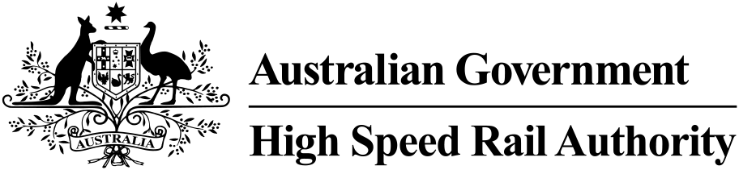

Corporate Plan

2023–24 to 2026–27

[**hsra.gov.au**](https://hsra.gov.au)

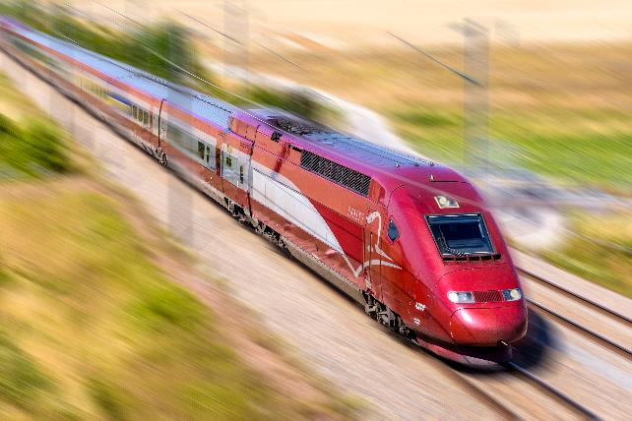

## Acknowledgement of Country

In the spirit of reconciliation, the High Speed Rail Authority acknowledges the Traditional Custodians of country throughout Australia and their connections to land, sea and community. We pay our respect to their Elders past and present and extend that respect to all Aboriginal and Torres Strait Islander peoples today.

© Commonwealth of Australia 2023

ISSN 2981-8796 (Online)

August 2023

Ownership of intellectual property rights in this publication

Unless otherwise noted, copyright (and any other intellectual property rights, if any) in this publication is owned by the Commonwealth of Australia (referred to below as the Commonwealth).

Disclaimer

The material contained in this publication is made available on the understanding that the Commonwealth is not providing professional advice, and that users exercise their own skill and care with respect to its use, and seek independent advice if necessary.

The Commonwealth makes no representations or warranties as to the contents or accuracy of the information contained in this publication. To the extent permitted by law, the Commonwealth disclaims liability to any person or organisation in respect of anything done, or omitted to be done, in reliance upon information contained in this publication.

Creative Commons licence

Creative Commons Attribution 4.0 Australia Licence

With the exception of (a) the Coat of Arms; (b) the Department of Infrastructure, Transport, Regional Development, Communications and the Arts photos and graphics copyright in this publication is licensed under a Creative Commons Attribution 4.0 Australia Licence.

Creative Commons Attribution 4.0 Australia Licence is a standard form licence agreement that allows you to copy, communicate and adapt this publication provided that you attribute the work to the Commonwealth and abide by the other licence terms.

Further information on the licence terms is available from <https://creativecommons.org/licenses/by/4.0/>

This publication should be attributed in the following way:

©Commonwealth of Australia 2022

Use of the Coat of Arms

The Department of the Prime Minister and Cabinet sets the terms under which the Coat of Arms is used. Please refer to the Commonwealth Coat of Arms – Information and Guidelines publication available at

Commonwealth Coat of Arms Information and Guidelines | Department of the Prime Minister and Cabinet ([pmc.gov.au](http://pmc.gov.au))

Publication Contact

This publication is available in PDF format online together with the HSRA’s Portfolio Budget Statements and Annual Reports on [Transparency.gov.au](https://transparency.gov.au) and the [HSRA’s website](https://www.hsra.gov.au). All other rights are reserved, including in relation to any departmental logos or trademarks which may exist. For enquiries regarding the licence and any use of this publication, please contact:

Director Corporate and Secretariat  
High Speed Rail Authority  
GPO Box 594  
Canberra ACT 2601  
Australia

Email: [info@hsra.gov.au](mailto:info%40hsra.gov.au?subject=)

Website: [www.hsra.gov.au](http://www.hsra.gov.au)

Publication Acknowledgement

The HSRA is proud to support small business.

Graphic design – [Keep Creative](http://www.keepcreative.com.au)

## Chair’s Foreword

High Speed Rail is a transformative project for Australia, which will stimulate employment and skills development through its planning and delivery phases, and, once delivered, will provide significant benefits to communities, individuals and industry. These include to enhance connectivity between cities and regional communities on Australia’s east coast through providing a fast travel alternative, enabling improved liveability and sustainable settlement patterns, providing strong sustainability outcomes, additional employment and the development of new industries.

It is not unusual for intergenerational projects, such as high speed rail, to be considered over multiple decades, given their sheer scale, complexity and cost. The Australian Government set its vision for high speed rail in Australia, establishing the High Speed Rail Authority (HSRA) in June 2023, and recognises the critical foundation and planning activities that need to take place, to ensure high speed rail can be appropriately sequenced, and successfully delivered in stages, including an early focus on the planning and corridor works for the Sydney to Newcastle section.

The HSRA Board is committed to working transparently, and within a framework of high standards of governance and accountability. The Board is enthusiastic about the important foundational and planning activities it will be overseeing in FY2023–24, as it works to build the HSRA with a strong leadership team, organisational capability, positive culture and transparent processes and decision making. It is important to acknowledge the rapidly evolving external environment and the challenges present in planning for the delivery of what will ultimately comprise a more than 1,700km high speed rail network. Key amongst these is supporting Australia to meet its global emissions reduction commitments and driving social and economic opportunities.

Of paramount importance to the HSRA is ensuring the upfront work identified in this Corporate Plan is appropriately scoped and thorough, that it draws on the deep industry experience in Australia as well as lessons from international high speed rail projects, and is underpinned by collaboration and developing strong relationships with our key stakeholders.

I look forward to working with my Board colleagues and the HSRA interim CEO, Andrew Hyles as we embark on this important and exciting journey.

As the accountable authority, the HSRA Board are pleased to present our inaugural Corporate Plan for the period 2023–24 to 2026–27 as required under paragraph 35(1)(b) of the Public Governance, Performance and Accountability Act 2013 and Part 5, Section 48 of the High Speed Rail Authority Act 2022.

Jill Rossouw  
Chair, High Speed Rail Authority

25 August 2023

Contents

Acknowledgement of Country 2

Chair’s Foreword 3

Introduction 5

Section 1 Purpose 6

Functions 8

Structure 8

Section 2 Key Activities and Performance 9

Key activities 10

Performance 11

Section 3 Operating Context 14

Our Environment 15

Capability 18

Risk Oversight and Management 19

Partnerships and Cooperation 20

## Introduction

The Australian Government committed to the establishment of the High Speed Rail Authority (HSRA) to oversee the development of the high speed rail (HSR) network along the east coast of Australia from Melbourne to Brisbane.

The HSRA was established under the High Speed Rail Authority Act 2022 (HSRA Act) and formally commenced operations on the 13 June 2023. The HSRA is an independent statutory authority overseen by a Board comprising a chair and four board members who are supported by a secretariat. The HSRA Chief Executive Officer is responsible for the day-to-day administration and is the Head of the Statutory Authority, for the purposes of the Public Service Act 1999.

For the purposes of the Public Governance, Performance and Accountability Act 2013 (PGPA Act), the HSRA is a corporate Commonwealth entity and is required to produce an annual report.

As an organisation in its establishment phase, the HSRA recognises the importance of ensuring it effectively transitions and builds its organisational capacity and capability to lay the foundations to successfully deliver on its core purpose and objectives. The next annual update of the HSRA Corporate Plan will factor in the outcomes of detailed strategic and organisational design planning.

This Corporate Plan aligns with the Statement of Expectations issued by the Minister for Infrastructure, Transport, Regional Development and Local Government, the Hon Catherine King MP, on 4 August 2023. Like the Statement of Intent issued by the HSRA in response, our Corporate Plan outlines our commitment to achieve the Government’s expectations through the HSRA’s statutory functions and accountability obligations.

Our Corporate Plan outlines HSRA’s:

**Purpose:** who we are, what we will do and how we will measure our performance in achieving our purpose.

**Key Activity and Performance:** builds on our functions, as set out in the HSRA Act, and the strategic direction and priorities established by the HSRA Board, which are aligned with direction set by the Australian Government and the Minister for Infrastructure, Transport, Regional Development and Local Government, the Hon Catherine King MP.

**Operating Context:** our external environment, organisation, capability, risk oversight and management and key partnerships and collaboration.

# Section 1 Purpose

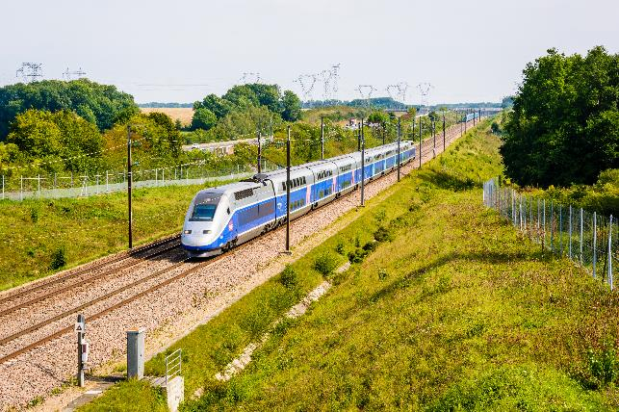

The HSRA is an independent and trusted advisor to the Australian Government on the development and delivery of a high speed rail network from Melbourne to Brisbane. As stated in Outcome 1 of the HSRA Portfolio Budget Statements (PBS), our purpose is to:

**Develop a high speed rail network between cities and key regional centres through policy development and planning, national coordination and strategic advice to enhance Australia’s long term rail investment.**

The HSRA has identified the following key elements to ensure our purpose is achieved.

 Expertise

As an independent statutory authority, the HSRA will leverage its expertise to progress the Australian Government’s HSR agenda. The HSRA will build and maintain credibility by leveraging the skills and capabilities of our people and our collaborative relationships so we are the expert respected voice to the Australian Government on HSR.

 Collaboration

Collaboration and partnerships will underpin and strengthen all that we do in supporting the Government to develop an east coast HSR network. The HSRA is committed to effective stakeholder engagement that builds trust, leverages common opportunities and drives consensus. Working in close partnership with states and the ACT, we will ensure all interested stakeholders have an opportunity to engage as projects are planned and delivered.

 Inform

HSRA will leverage its expertise and collaboration with stakeholders to provide informed analysis, advice and recommendations to the Australian Government, the Minister for Infrastructure, Transport, Regional Development and Local Government and other parties. The HSRA will shape the strategic agenda through comprehensive research and analysis, rigorous and evidence based policy and robust program administration.

 Governance and Accountability

HSRA is committed to the highest standard of accountability and governance. Sound and effective oversight mechanisms and governance will guide and influence everything we do and be an essential element of our success. The HSRA is subject to the PGPA Act and additional governance requirements under our own Act.

## Functions

Section 8 of the HSRA Act, sets out the functions of the HSRA in relation to the high speed rail network, high speed rail corridor and related rail networks and corridors including the following functions:

* Lead and coordinate policy development and planning
* Consult, liaise and negotiate with States and Territories and other relevant parties
* Provide advice and recommendations to the Minister and other relevant stakeholders (including advice and recommendations on environmental matters and interconnectedness), and
* Undertake evaluations and research and gather information.

## Structure

The HSRA is an independent statutory authority and a corporate Commonwealth entity. The accountable authority of the HSRA is the Board. The Board is comprised of a chair and four board members who are supported by a secretariat. The members of the HSRA Board are:

* Jill Rossouw (Chair)
* Gillian Brown
* Ian Hunt
* Dyan Perry OBE
* Neil Scales OBE

The HSRA Chief Executive Officer is responsible for the day-to-day administration of the HSRA and manages operational activities in accordance with the strategic plan and direction provided by the Board. By the end of 2023, the HSRA will develop an organisational strategy that highlights capability building and resource needs.

Currently the HSRA is structured into two main functional streams comprising three sections in total responsible for the following:

HSR Engagement and Policy and HSR Network Planning and Design

Undertake key activities to support the development and execution of a strategic plan on how to deliver an east coast HSR network starting with the Sydney to Newcastle section.

The strategic plan will inform key milestone activities for planning east coast HSR (building on the 2013 Phase 2 Report) delivery of the Government’s commitment to planning and corridor protection along the Sydney to Newcastle corridor, development of strategies for engaging with other levels of government and to progress environmental approvals, and identification of route alignment and corridor protection options. As the scope of the HSRA’s work is further defined and progressed, the work of these two sections will further evolve.

Corporate and Secretariat

Support the operation of the HSRA including developing and managing high quality financial and governance outcomes, business services, systems and advice to enable it to deliver its respective responsibilities and activities in line with governance and accountability requirements under relevant legislation.

Support the HSRA Board through governance advice, secretariat services, effective administration of Board processes and outputs, facilitation of Board and governance reviews and ensuring effective information flows between the Board and HSRA management.

# Section 2 Key Activities and Performance

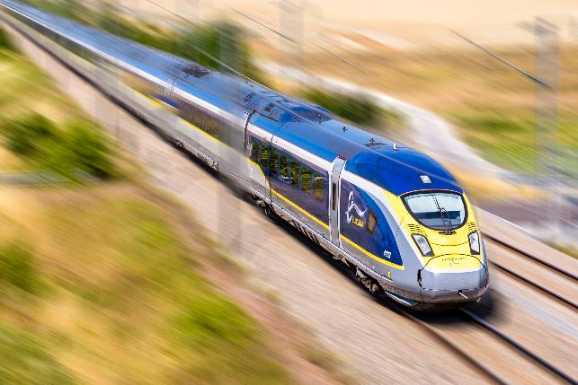

## Key activities

The key activities through which HSRA will achieve its purpose over the period of this Corporate Plan include:

|  |  |  |  |  |
| --- | --- | --- | --- | --- |
| Key activities | 2023–24 | 2024–25 | 2025–26 | 2026–27 |
| Set out a clear **strategic plan** on how to develop and deliver the Australian Government’s HSR priorities. |  |  |  |  |
| Develop an **organisational strategy** to ensure the HSRA has the capability and resources required, including the appointment of a permanent Chief Executive Officer to head the Authority. |  |  |  |  |
| Develop a **communications strategy** that includes identifying relevant stakeholders and defining suitable timing of engagement with them. |  |  |  |  |
| Undertake **evaluations, research and gather information** to provide robust advice to the Australian Government on planning and delivery of HSR. |  |  |  |  |
| **Consult, liaise and negotiate** with States and Territories and other relevant parties to identify rail corridors, obtain necessary environmental assessments and planning approvals, and set up bilateral agreements where necessary. |  |  |  |  |
| Lead and coordinate HSR related **policy development and planning**. |  |  |  |  |
| **Provide informed and evidence based advice and recommendations** to the Minister and other relevant parties on HSR matters (including advice and recommendations on opportunities to enhance environmental and sustainability outcomes and interconnectedness). |  |  |  |  |

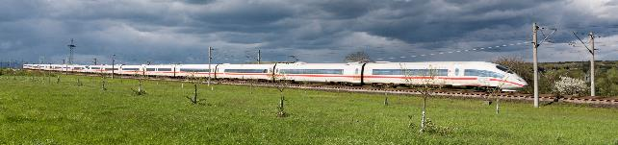

## Performance

The HSRA has the following measures in place to determine the effectiveness of our key activities against our purpose.

### Outcome 1

**Developing a high speed rail network between capital cities and key regional centres through policy development and planning, national coordination and strategic advice to enhance Australia’s long term rail investment.**

#### Program 1.1 – Advice supports the Australian Governments objectives for high speed rail.

|  |  |  |  |  |
| --- | --- | --- | --- | --- |
| Performance Measure | 2023–24 target | 2024–25 to 2026–27 target | Benefit | Data source |
| Develop a risk management policy and framework. | By the end of 2023, a risk management policy and framework will be developed that will govern how the HSRA identifies, manages and communicates risk. | To be regularly reviewed to ensure it reflects the HSRA’s operating environment. | Provide confidence that the HSRA has established, and has arrangements for maintaining an appropriate system of risk oversight and management that will support the HSRA in achieving its purpose. | HSRA Board and ARC minutes endorsing the risk policy and framework  Annual Report |
| Develop an organisational strategy which includes capability building. | By the end of 2023, an organisational strategy will be developed that provides a road map for developing the organisation and its workforce capability and resource needs to deliver the outcome. | Annual review of the strategy to ensure it is fit-for-purpose. As the organisation’s work program develops and progresses, the organisations capability and resource needs will evolve. | By having the right structure, resources, capabilities and skills in place within the HSRA, we will maximise the quality and value of the advice we provide to the government and stakeholders. | HSRA Board and ARC minutes endorsing the organisational strategy  Organisational strategy document |
| Develop a communications and stakeholder engagement strategy. | By early 2024, a communications and stakeholder engagement strategy will outline a framework, including objectives and timeframes, for the HSRA to engage with key stakeholders on key initiatives and actions the HSRA will take. | Annual review of strategy to ensure it is fit-for-purpose. | The strategy will assist the HSRA in building positive relationships and engagements with stakeholders as well as create effective communication, transparency and trust in the work and actions of the HSRA. | HSRA Board and ARC minutes endorsing the communications and stakeholder engagement strategy  Communications and stakeholder engagement strategy document |
| Appoint a permanent Chief Executive Officer to head the Authority. | By early 2024, a Chief Executive Officer will have been permanently appointed. | N/A | A permanent Chief Executive Officer will provide strategic day-to-day oversight of the HSRA, ensure stability and assist the HSRA in meeting its operational activities and objectives. | Appointment announcement |
| Build on the 2013 High Speed Rail Phase 2 Report to support strategic planning for an east coast HSR network and development of business cases. | A review of the 2013 Phase 2 Report, Pathway to Delivery Report for an east coast HSR network and business case for HSR on the Sydney to Newcastle corridor are commissioned and work is underway in partnership with relevant states and the ACT. | By the end of 2024–25, complete an east coast HSR network Pathway to Delivery Report underpinned by a review of the 2013 Phase 2 Report. This will include identification of route alignment, station locations, costs and benefits, city shaping and land use opportunities, emissions reduction and environmental impact mitigation strategies, financing delivery options, commercial interfaces and interoperability.  A business case for the Sydney to Newcastle section will be completed in 2025–26 and presented to the Government for investment consideration. | Informed by engagement with key stakeholders, the east coast HSR network Pathway to Delivery Report will provide a strategic road map for delivering the network. A business case for the Sydney to Newcastle section will support advice to government about potential funding opportunities. | Government assessment of HSRA’s response to the Phase 2 Report, the east coast HSR network Pathway to Delivery Report and other related documents and discussion papers  East coast HSR network Pathway to Delivery Report document  Business case for Sydney to Newcastle document |
| Develop a strategy to progress state and federal environmental approvals. | By the end of 2024, a strategy to progress state and federal environmental approvals, including a stocktake of the existing frameworks and options for addressing any challenges associated with location-specific issues. | N/A | Informed by engagement with state and ACT governments, the strategy to progress state and federal environmental approvals will ensure future HSR projects are enabled by efficient and effective assessment and approval processes. | HSRA Board and ARC minutes endorsing environmental strategy  Environmental strategy document |
| Develop a strategy to progress state and local agreements necessary to realise construction. | By the end of 2024, a governance strategy to progress state and local agreements to support delivery of HSR construction projects. | N/A | Underpinned by the stakeholder engagement strategy, the strategy to progress state and local agreements will ensure the smooth, timely and effective delivery of future high speed rail projects. | HSRA Board and ARC minutes endorsing strategy  Governance strategy document |



### Measurement

The milestones and expectations that make up the HSRA’s performance target for 2023–24 will be assessed against whether achieved, partially achieved or not achieved. Evidence to support the performance measure assessment will form the basis of the HSRAs Annual Performance Statement.

### Factors that could influence performance

The decisions made by the Australian Government and support from state and territory governments may impact on the HSRA to achieve the recorded targets.

# Section 3 Operating Context

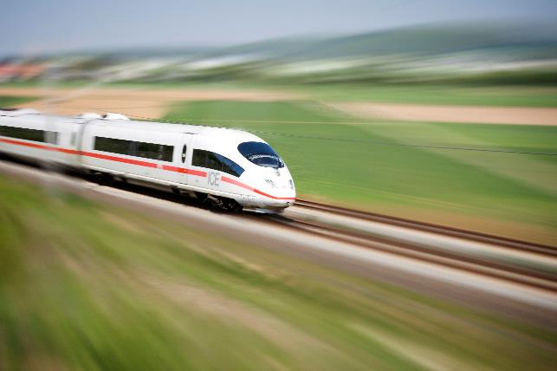

## Our Environment

The external environment, both in Australia and globally, is evolving rapidly, and has been impacted by, amongst other things, structural shifts that occurred during and following the COVID–19 pandemic, geopolitical factors, macroeconomic factors (including low unemployment combined with high inflation), as well as the impacts of climate change and acceleration to net zero carbon emissions.

Understanding, adapting and responding to changes in our operating environment are critical to delivering on the HSRA’s purpose. This will be achieved through regular engagement with our stakeholders and by recruiting and retaining a skilled, resilient and capable workforce to provide expert advice and support to the Australian Government.

The factors and changes that may influence the HSRA’s operating environment over the next four-year period are detailed in this Corporate Plan. The identified factors are likely to be exacerbated by ongoing pressures in the supply of labour and materials. In particular, the global economy continues to battle significant disruption to supply chains caused by the pandemic, volatile demand and global conflict. These are in turn causing delays and cost escalations for imported items and shortages in the required skills for rail projects present risks to the capacity of project proponents to deliver large complex projects.

Without careful planning, the increase in uncertainty in the infrastructure market may lead to project delays and significant cost overruns.



### Australia is an urbanised nation

Australia continues to be one of the most urbanised nations in the world with around 67 per cent of Australians living in capital cities. After declining during the COVID–19 pandemic, Australia’s capital city population growth has returned with Brisbane (up 59,200 or 2.3 per cent) and Melbourne (up 55,000 or 1.1 per cent) growing the most in 2021–22, and Sydney increasing by more than 30,000 people (0.7 per cent). This growth in population is driven by a combination of natural increases (births and longer life spans due to higher living standards offsetting deaths) and net overseas migration. Australia’s population is forecast to grow to around 30 million people by 2033–34 based on an average yearly increase in population of 1.4 per cent.

Australia’s largest capital city is Sydney with 5.3 million residents followed by Melbourne and Brisbane with 5.0 and 2.6 million residents respectively. Canberra is Australia’s sixth largest capital with a population of over 456,000 people. The Australian Government’s Centre for Population forecasts Melbourne to become Australia’s largest city by 2032 – its population is forecast to reach 6.1 million residents, followed by Sydney with a forecast 6 million residents and Brisbane with over 3 million residents.

### High speed mass transit services will lower carbon emissions

On 16 June 2022, through the Paris Climate Agreement, the Australian Government updated its commitment to reduce greenhouse gas emissions by 43 per cent below 2005 levels by 2030. The transport sector is a key contributor to net emissions, with road vehicles the largest contributor (over 85 per cent) followed by domestic aviation (9 per cent).

Australia’s aviation market is returning to pre-pandemic activity with 55 million passengers carried in the year to April 2023. Melbourne – Sydney remains Australia’s busiest passenger transport route by air, and one of the busiest in the world, with seven million domestic passengers in the year to December 2022, an increase of 230 per cent compared with the previous calendar year. This was followed by Brisbane – Sydney, with 3.6 million passengers (up 230 per cent), and Brisbane – Melbourne, with 2.8 million passengers (up 260 per cent), as the second and third busiest passenger air corridors.

Improved high speed mass-transit rail connections between Australia’s major capital cities can reduce transport emissions by providing travellers with a viable low emissions alternative transport mode. Analysis of the Carbon Footprint of High Speed Rail in Europe by the International Union of Railways for example indicates that, even when construction emissions are factored in, the carbon footprint of HSR (including operation, track construction and rolling stock construction) is about 14 to 16 times less than transport by private car or aeroplane in Europe.

The French Parliament recently implemented measures to prevent flights being made on domestic routes that are possible in less than two-and-a-half hours by train – a measure cited as a major step forward in the policy of reducing greenhouse gas emissions. These new laws were subsequently approved by the European Union in December 2022.

Reducing air and road transport demand along Australia’s east coast will not only directly reduce transport emissions, it will also reduce traffic congestion, which will further reduce emissions, and other impacts of climate change such as flooding and fires.

### Fast interconnected mass transport is key to sustainable population growth

Although the regions surrounding our major capital cities are among the fastest growing areas in Australia, most of the future population growth will be concentrated in capital cities, unless deliberate government policy changes intervene. This growth does however come with significant potential negative impacts for capital city residents, including lack of housing and its affordability, rising traffic congestion, increasing urban development, environmental pollution and increasing social inequality.

Supporting the development of interconnected regions – particularly along Australia’s most populated eastern seaboard – enabled by resilient and efficient high speed transport will help to promote more sustainable population and economic growth. Spreading population growth along Australia’s east coast will enhance regional economic growth and resilience, improve employment outcomes, enhance social connectedness and lead to better quality of life.

Leveraging rail infrastructure to drive socio-economic improvements will also ensure Australia maintains its position as one of the most liveable places in the world and put downward pressure on costs of living.

### Manufacturing industry and skills

Australia’s rail network plays a key role in our economy, facilitating the transportation of passengers across major capital cities and regions and supporting the flow of goods to and from import/export ports. Our rail system is currently undergoing a significant transformation with the National Rail Action Plan estimating $155 billion pipeline of rail projects currently underway. This investment will see rail assuming a more prominent role in shaping future social and economic outcomes in this country.

The rail manufacturing sector currently employs 5,000 workers in direct rail roles, with an additional 7,000 employed indirectly in the extended supply chain. To ensure the efficient delivery and ongoing operation of major rail projects, Australia must actively work towards expanding the rail workforce supported by both traditional and new economy skills. Without active steps to promote workforce and skills development, the industry is likely to face a significant shortage of skilled workers.

An east coast HSR network provides the opportunity to support diversification and wider distribution of manufacturing and service sector industries. By providing the mass transit backbone connecting various urban and regional areas, east coast HSR will not only connect major job centres with skilled workforces but will also enable a shift in the location of major manufacturing centres away from expensive outer capital areas to more affordable regional centres. This will in turn contribute to a more resilient and thriving economy.

### Improving transport access supports changes in settlement patterns

Population and employment growth will continue to challenge the capacity of existing transport networks and public infrastructure along the east coast of Australia. Estimates suggest that Australia’s population could grow by 12 to 14 million people by 2050. Various scenarios exist for how this growth in population will influence settlement patterns over time however, in the absence of sustainable, high speed mass transport systems that connect major capital cities and regional areas, this population growth is likely to concentrate in major capitals and further exacerbate population growth pressures and urban sprawl.

## Capability

A strong capability culture is critical to achieving our purpose, supporting the Australian Government’s priorities and serving the interests of all Australians. As a new Authority, we will ensure we build our in-house capability by creating fit-for-purpose structures, processes and technology which will allow us to recruit high calibre people and teams, and where necessary bring in specialist external support. We will also work to build capability by evaluating our core skills and capability and investing in the development of our people. We will strive to engage a committed, skilled, resilient and experienced work force (both in-house and through specialist external support) to provide expert advice and support to the Australian Government’s HSR agenda.

The HSRA will enhance its capability and capacity over the period of this Corporate Plan to support our purpose. We will do this inter alia by:

Our People

* Finalising establishment activities including the recruitment of skilled permanent staff and the creation of a People Strategy.
* Investing in and strengthening professional capabilities of the HSRA employees to align our workforce with our operating environment.
* Drawing in external specialists where appropriate.

Our Culture & Wellbeing

* Upholding a culture that supports HSRAs values through effective communication and engagement within the HSRA and across the Commonwealth.
* Ensuring HSRA employees actively engage in the successful delivery of our purpose and are supported by an inclusive, flexible, positive and safe workplace culture.

Our Workplace

* Maintaining an efficient and effective governance and corporate structure and continuously improving what we do and how we do it.
* Maintaining flexible and agile ways of working by providing our staff with functional remote working arrangements and digital collaboration tools.
* Ensuring our workplace is safe for our employees.
* Strengthening partnerships and drawing on benchmarks for State Government and international counterparts.
* Indentifying positive good practice internationally.

Our Stakeholders

* Working collaboratively and transparently with our portfolio department to ensure that our actions and activities align with the Government’s broader transport agenda, programs, policies and governance procedures.
* Strengthening our partnerships by maintaining collaborative stakeholder engagement with states and territory governments.
* Ensuring that local communities and other interested parties are kept well informed of our work and our plans and in turn help to inform them.

## Risk Oversight and Management

As a corporate Commonwealth entity, the HSRA manages risk in accordance with section 16 of the PGPA Act and whilst not required to comply with the Commonwealth Risk Management Policy, the HSRA will adopt an approach consistent with the policy to ensure a robust system of risk management as a matter of good practice.

The HSRA’s risk management policy and framework is currently being developed as part of the establishment phase and will be presented to HSRA’s Audit and Risk Committee and Board for endorsement and approval at the August and September 2023 meetings respectively.

Once established, the policy and framework will detail the HSRA’s approach to managing and engaging with risk, including risk appetite and tolerance levels, embedding a positive risk culture that empowers employees at all levels to make effective decisions to achieve objectives, improve performance and encourage innovation. To support this approach, the framework will outline the key accountabilities, roles and responsibilities of employees in managing risks and implementing the framework. The aim of the policy and framework is to ensure the HSRA makes informed decisions with respect to the activities that it undertakes by appropriately considering both risks and opportunities.

By considering both risks and opportunities, the HSRA recognises it is not always possible or necessary to eliminate all the risks inherent in our work. By accepting some degree of risk in business practices, the HSRA can promote efficiency and innovation, with some willingness to accept higher levels of risk where the potential benefits outweigh the negative consequences through informed and evidence based decision making.

The HSRA policy and framework will encompass a suite of systems, documents, policies, guidelines and processes to support how the HSRA will identify, manage and communicate risk via the following mechanisms:

**DIRECTIVE**

Commonwealth Risk Management Policy

HSRA Risk Management Policy and Framework

HSRA Risk Management Plan

Accountable Authority Instructions

Corporate Plan

**MEASURING**

Audit & Risk Committee oversight

Audit program which aligns with Risk Management Policy and Framework

Monitoring HSRA Risk Management Plan

Risk registers

Business Continuity Planning

Fraud and Corruption Control Planning

Work Health and Safety

Risk Management Framework monitoring and review

Annual Comcover Risk Survey

Strategic Risk Review

**REPORTING**

Annual Report

Annual Performance Statement

Quarterly performance report

Risk review agenda item at Executive meetings

**PEOPLE**

Leadership and management demonstrate and discuss the importance of managing risk appropriately in a positive and consistent manner

Positive risk culture built into day-to-day practices of all staff

Supportive environment for escalating risk issues

Ongoing education in respect to risk and compliance

Lessons learned sessions to assist with risk management



## Partnerships and Cooperation

Cooperation, collaboration and partnerships will underpin and strengthen all that we do, and the advice that we provide to the Minister and Government about the development of an east coast HSR network. Maintaining strong collaboration with all levels of government will be a priority to ensure our advice is robust and our plans can be effectively and efficiently implemented. Cooperation, collaboration and partnerships will also be critical to progressing the development and delivery of our key milestones efficiently and effectively. We will work closely and in partnership with a number of departments and agencies including our portfolio Department (the Department of Infrastructure, Transport, Regional Development, Communications and the Arts), central agencies, the Department of Climate Change, Energy, the Environment and Water, Infrastructure Australia and Government Business Enterprises as necessary.

We will also work closely with the NSW, Victoria, Queensland and ACT governments and their relevant departments to progress strategic planning for an east coast HSR network. This will focus initially on NSW for the delivery of the Australian Government’s commitment to progress planning and corridor protection along the Sydney to Newcastle section of their network. These states and the ACT are critical partners and close, collaborative engagement with them during all phases of planning and delivery will be instrumental to the success of the HSRA.

The HSRA will also seek out and be informed by guidance and advice from both Australian and international experts with expertise in the delivery of major nation-shaping infrastructure projects and HSR rail lines. Understanding and incorporating lessons learned from other major transport projects will help to strengthen and broaden our advice, our planning and our project delivery.



[**hsra.gov.au**](https://hsra.gov.au)